Project Report
on

Frontend Web Development Projects
Submitted
In Partial Fulfillment of
BACHELOR’S OF COMPUTER APPLICATIONS (BCA)
Submitted by:
- Pooja
24/SCA/BCA/035

Under the Supervision of:
Ms. Iram Fatima , Assistant Professor
School of Computer Applications


School of Computer Applications
Manav Rachna International Institute of Research and Studies
(DEEMED TO BE UNIVERSITY)
Sector-43, Aravalli Hills
Faridabad – 121001

June 2025

Declaration

I do hereby declare that this project work entitled “Frontend Web Development Projects using HTML, CSS & JavaScript "submitted by me for the partial fulfillment of the requirement for the award of BACHELOR OF COMPUTER APPLICATIONS is a record of my own work. The report embodies the finding based on my study and observation and has not been submitted earlier for the award of any degree or diploma to any Institute or University.

Signature of the Student
Name: Pooja
RollNo: 24/SCA/BCA/035

Certificate from the Guide

This is to certify that the project report entitled “Frontend Web Development Projects using HTML, CSS & JavaScript” submitted in partial fulfillment of the degree of BACHELOR’S OF COMPUTER APPLICATIONS to Manav Rachna International Institute of Research and Studies, Faridabad is carried out by Ms. Pooja (Roll No- 24/SCA/BCA/035) under my guidance.

Signature of the Guide

Head of Department
Name:
Date:

ACKNOWLEDGEMENT

I gratefully acknowledge the assistance, cooperation, guidance, and clarification provided by the CodSoft Internship Team during the development of my projects. My sincere thanks to the team at CodSoft for offering a practical and insightful training environment
My extreme gratitude to Dr. Raj Kumar, Associate Professor & TPO who guided us throughout the project. Without his willing disposition, spirit accommodation, frankness, timely clarification and above all faith in us, this project could not have been completed in due time. His readiness to discuss all important matters at work deserves special attention of.
I would like to extend my sincere gratitude to Prof. (Dr.) Suhail Javed Quraishi – HOD, Prof. (Dr.) Rashmi Agrawal – Associate Dean and Prof. (Dr.) Brijesh Kumar – Dean for their valuable teachings and advice. I want to thank all the department faculty members for their cooperation and support. I want to thank non-teaching staff of the department for their cooperation and support.
This opportunity is a big milestone in my career development. I will strive to use gained skills and knowledge in the best possible way, and I will continue to work on their improvement, to attain desired career objectives. I hope to continue cooperation with all of you in the future.

INDEX (TABLE OF CONTENTS)
Sr. No. | Content | Page No.
I | Cover Page | 1
II | Declaration | 2
III | Certificate | 3
IV | Acknowledgement | 4
V | Index | 5
VI | Introduction | 6
VII | System Study | 8
VIII | Feasibility Study | 21
IX | Project Monitoring System | 23
X | System Analysis | 25
XI | System Design | 29
XII | Input/Output Form Design | 36
XIII | System Testing | 42
XIV | System Implementation | 44
XV | Documentation | 50
XVI | Scope of the Project | 52
XVII | Bibliography | 55

INTRODUCTION

About CodSoft and Internship
CodSoft is an innovative tech-focused platform designed to bridge the gap between academic knowledge and industry expectations. It offers virtual internship programs that empower students and aspiring developers to gain hands-on experience through real-world, project-based learning .
During my internship from July 1 to July 30, 2025, I worked on three practical projects:
- Developing a personal portfolio website
- Building a calculator using HTML, CSS, and JavaScript
- Designing a landing page for a product or service
These tasks allowed me to apply front-end development skills in real scenarios, using core technologies such as HTML5, CSS3, and JavaScript to craft interactive and responsive web interfaces.
The internship emphasized independent learning and professional responsibility. Each project had clear deadlines and evaluation criteria, simulating real-world client work and enhancing my ability to write clean, maintainable code within set timelines.
Through this experience, I strengthened my skills in:
- Responsive web design
- User interface and user experience (UI/UX) design
- JavaScript programming fundamentals
- Version control and collaboration using GitHub

Overall, this internship marked a valuable transition from theoretical learning to practical web development, helping me build a strong foundation for a career in tech.

ManPower

1. Student Intern: Pooja
Role: Frontend Web Developer
Contributions:
- Successfully completed all assigned projects within the given timelines
- Delivered clean, well-structured, and maintainable code
- Demonstrated effective time management and a strong understanding of UI/UX design
2. CodSoft Internship Mentor
Role: Task Supervisor and Technical Evaluator
Responsibilities:
- Assigned project tasks and guided development direction
- Reviewed project code, assessed UI/UX quality, and validated final submissions
- Provided timely feedback and technical suggestions to improve performance
3. Institutional Support (MRIIRS)
Support Team: TPO & Faculty Mentors
Responsibilities:
- Assisted with documentation review and verification
- Guided the intern in preparing formal project reports and final presentations
- Monitored progress and offered continuous encouragement throughout the internship

The internship followed a well-organized and goal-oriented structure, offering maximum learning exposure and aligning closely with modern industry standards in web development.

SYSTEM STUDY
🔹 Portfolio Website
Existing System:
Previously, there was no personalized portfolio system for showcasing individual achievements, skills, and projects. Students typically shared static resumes or scattered project links via email or drive folders.

Proposed System
To overcome the challenges of static documents, a dynamic Portfolio Website was developed using HTML, CSS, and JavaScript. This digital portfolio presents the student’s information in a visually engaging and professionally designed layout.
It allows recruiters and collaborators to instantly understand a student’s skills, background, and capabilities by exploring their work online.

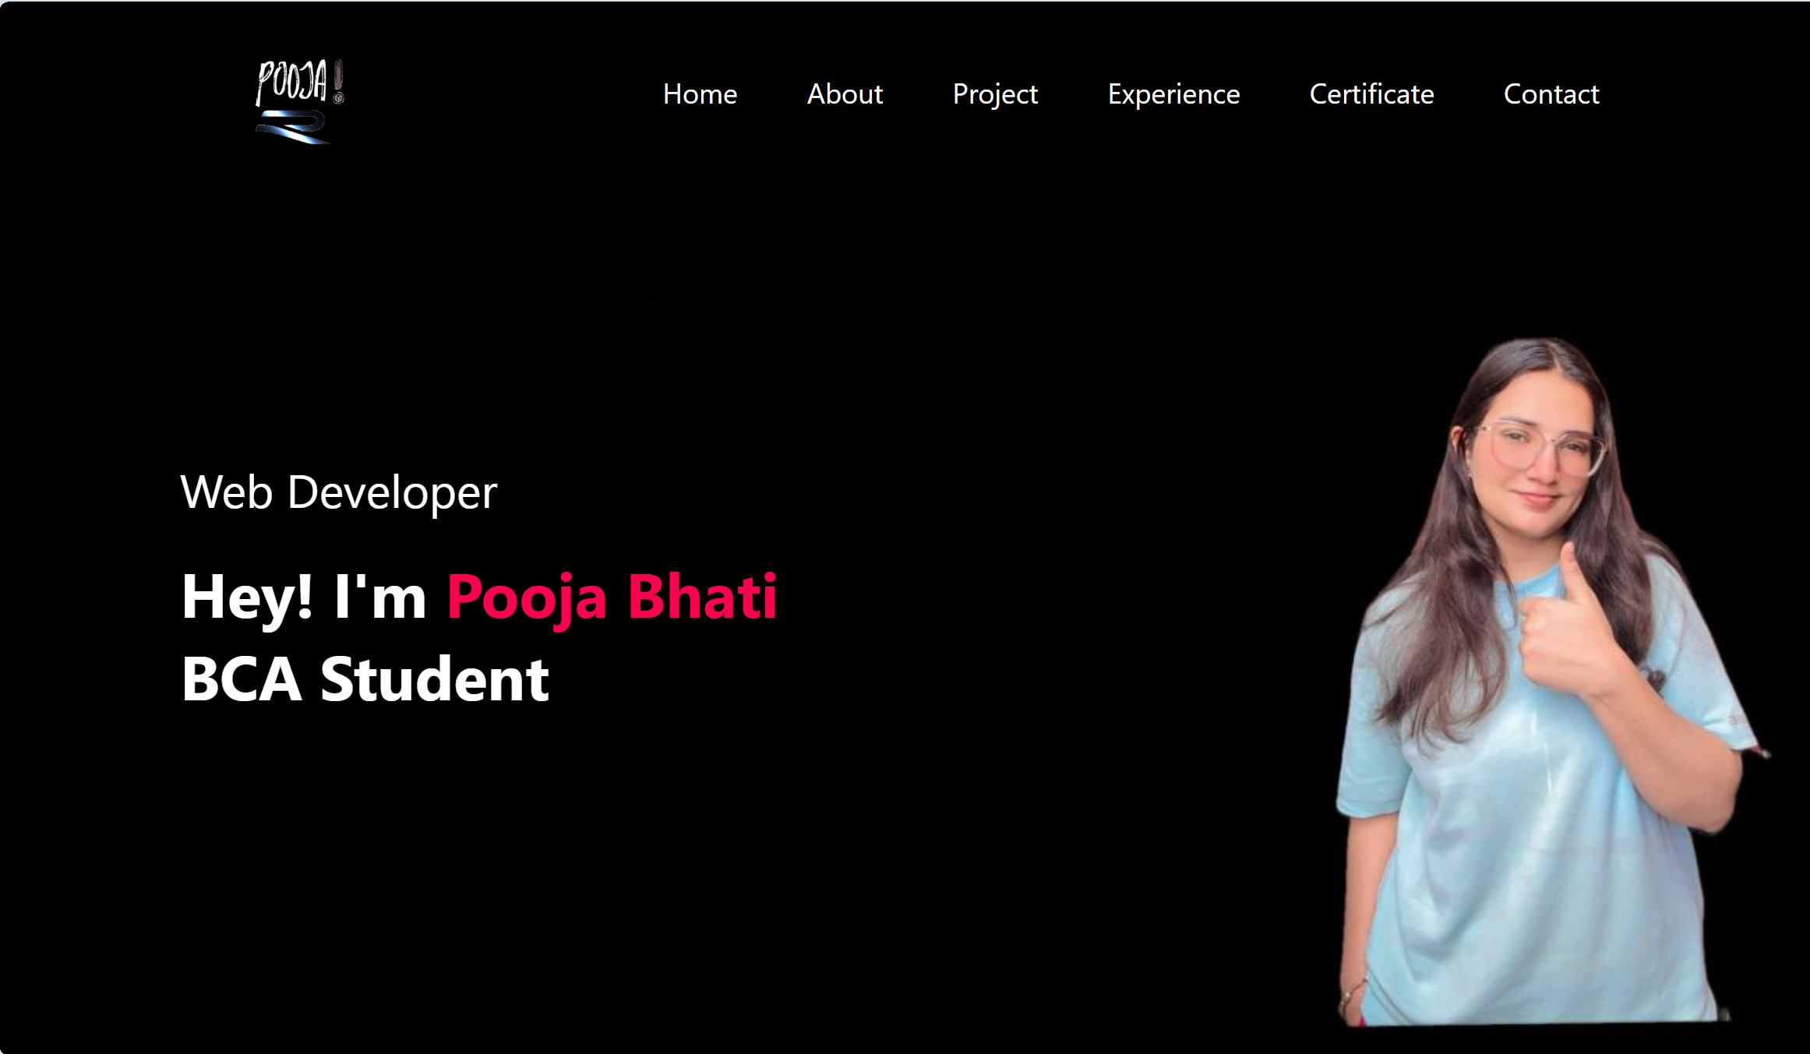
Fig:1.01 (portfolio)
Key Features:
- Responsive layout using HTML, CSS, JavaScript
- Sections: Home, About, Skills, Projects, Contact
- Form with validation
- Scroll animations, transitions, and hover effects
- Skill progress bars, icons, and downloadable resume
- Social media link integration
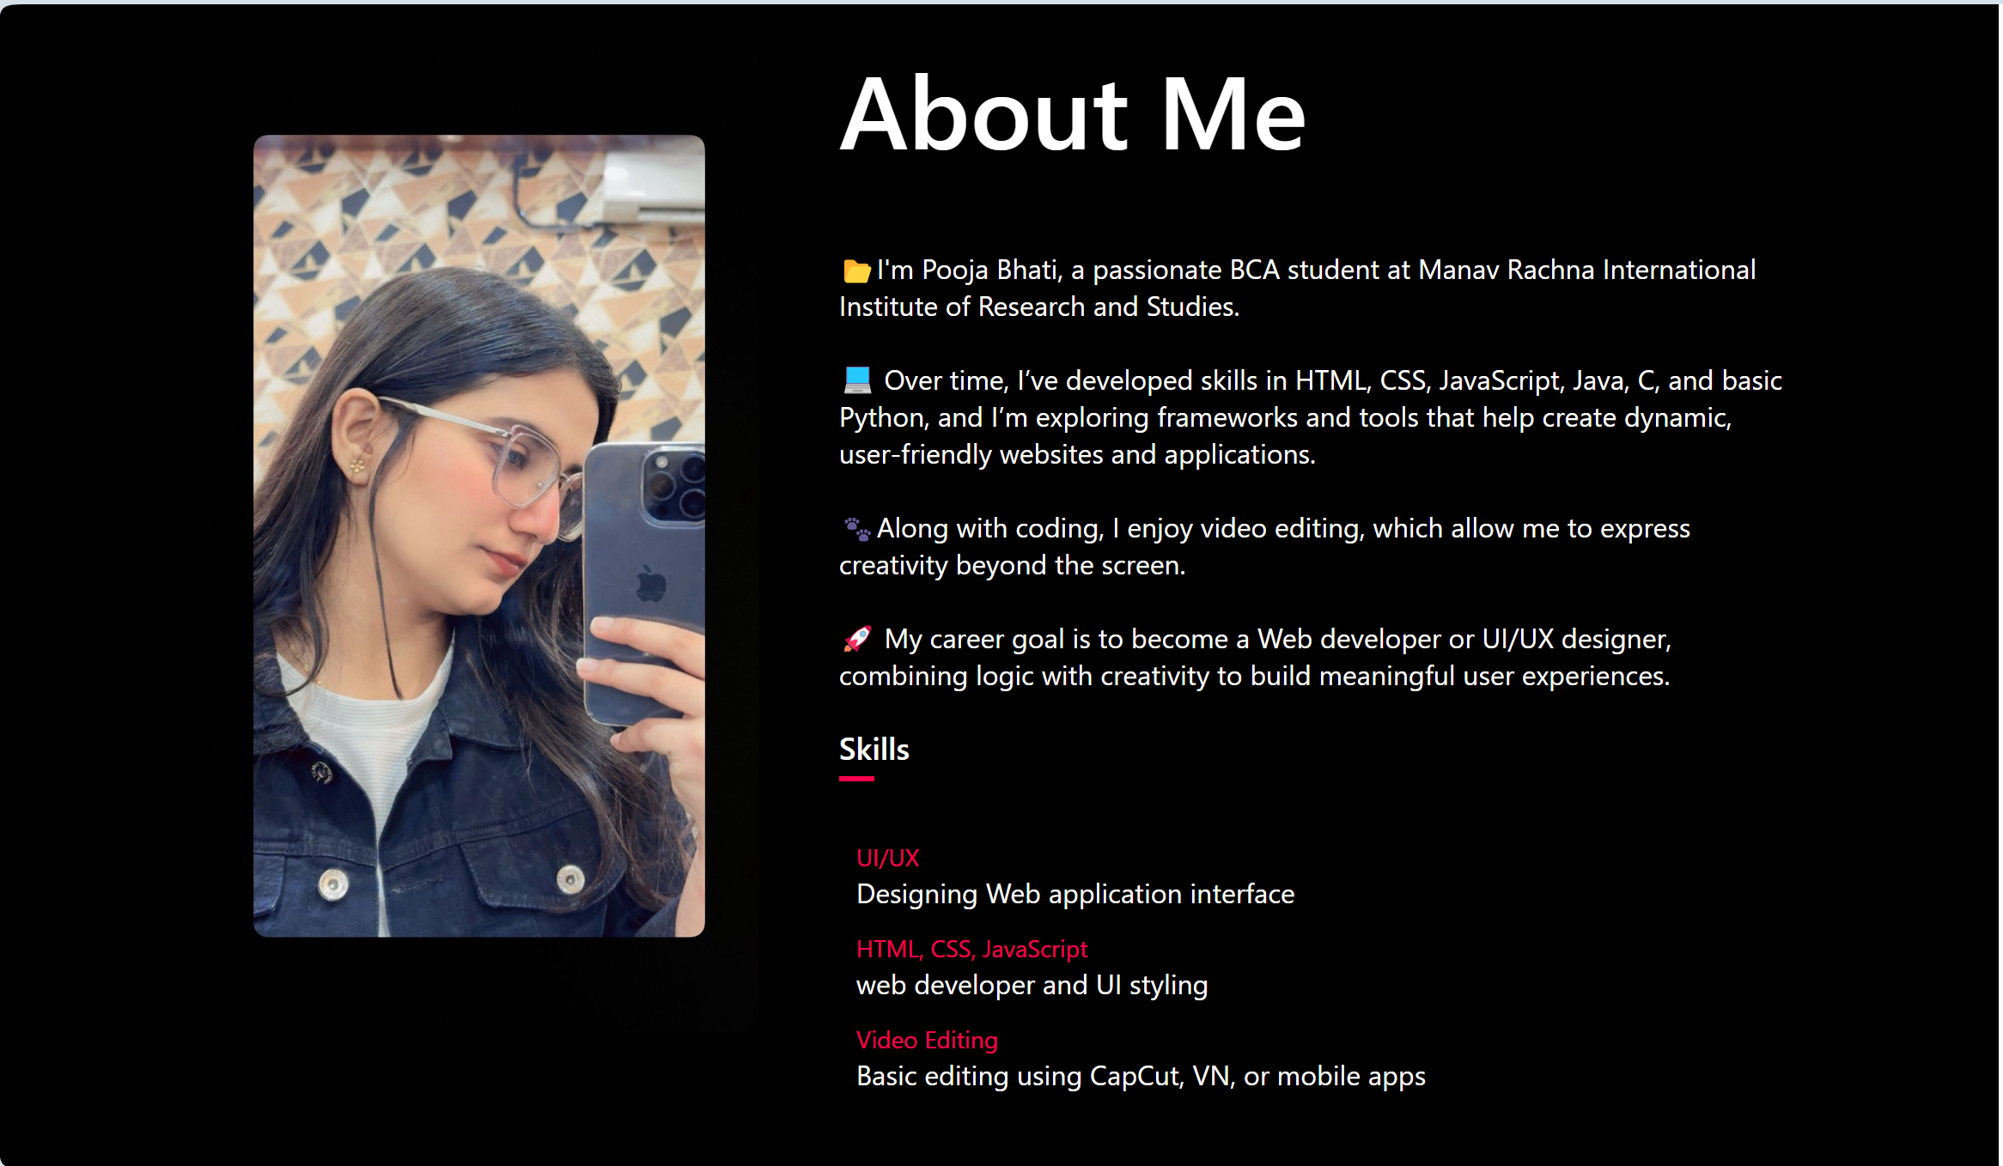
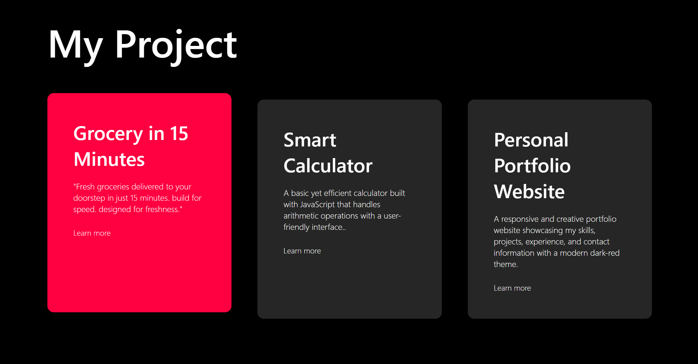
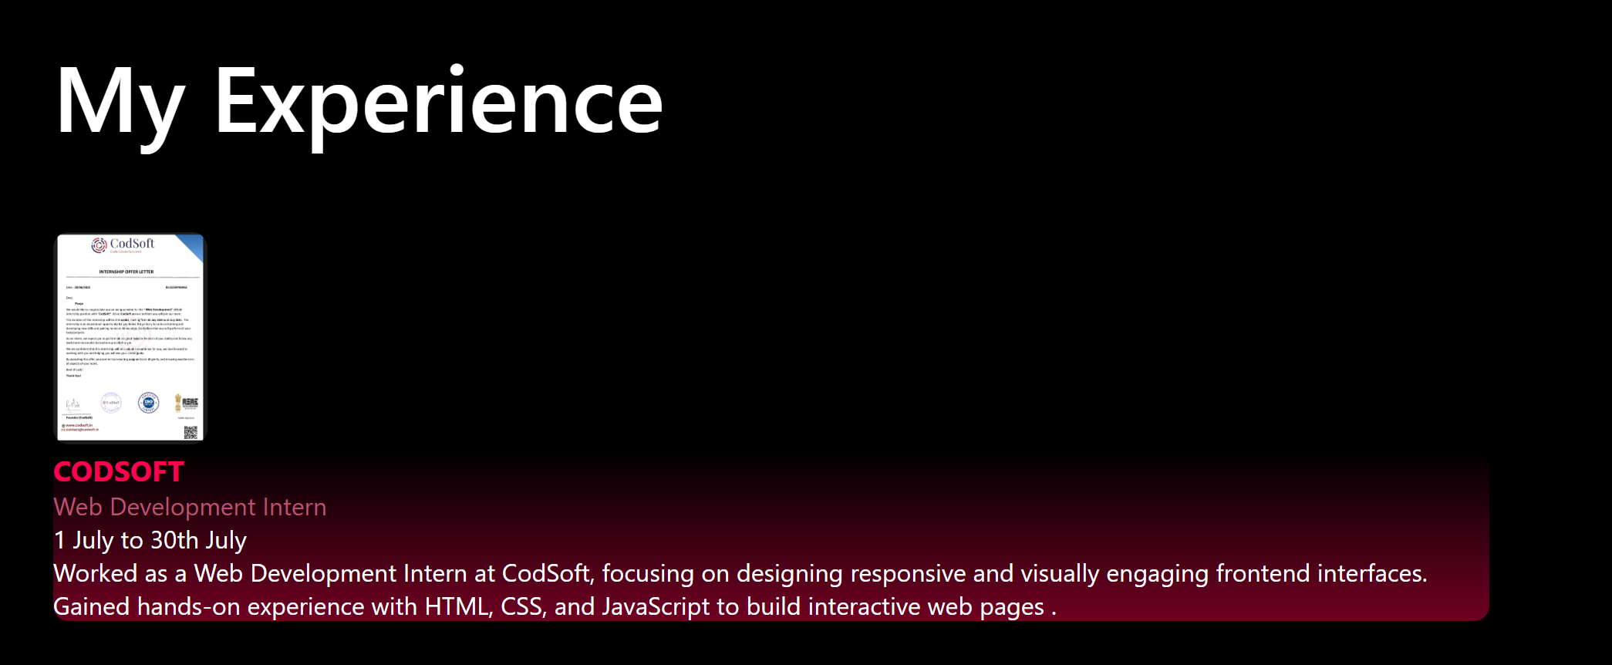

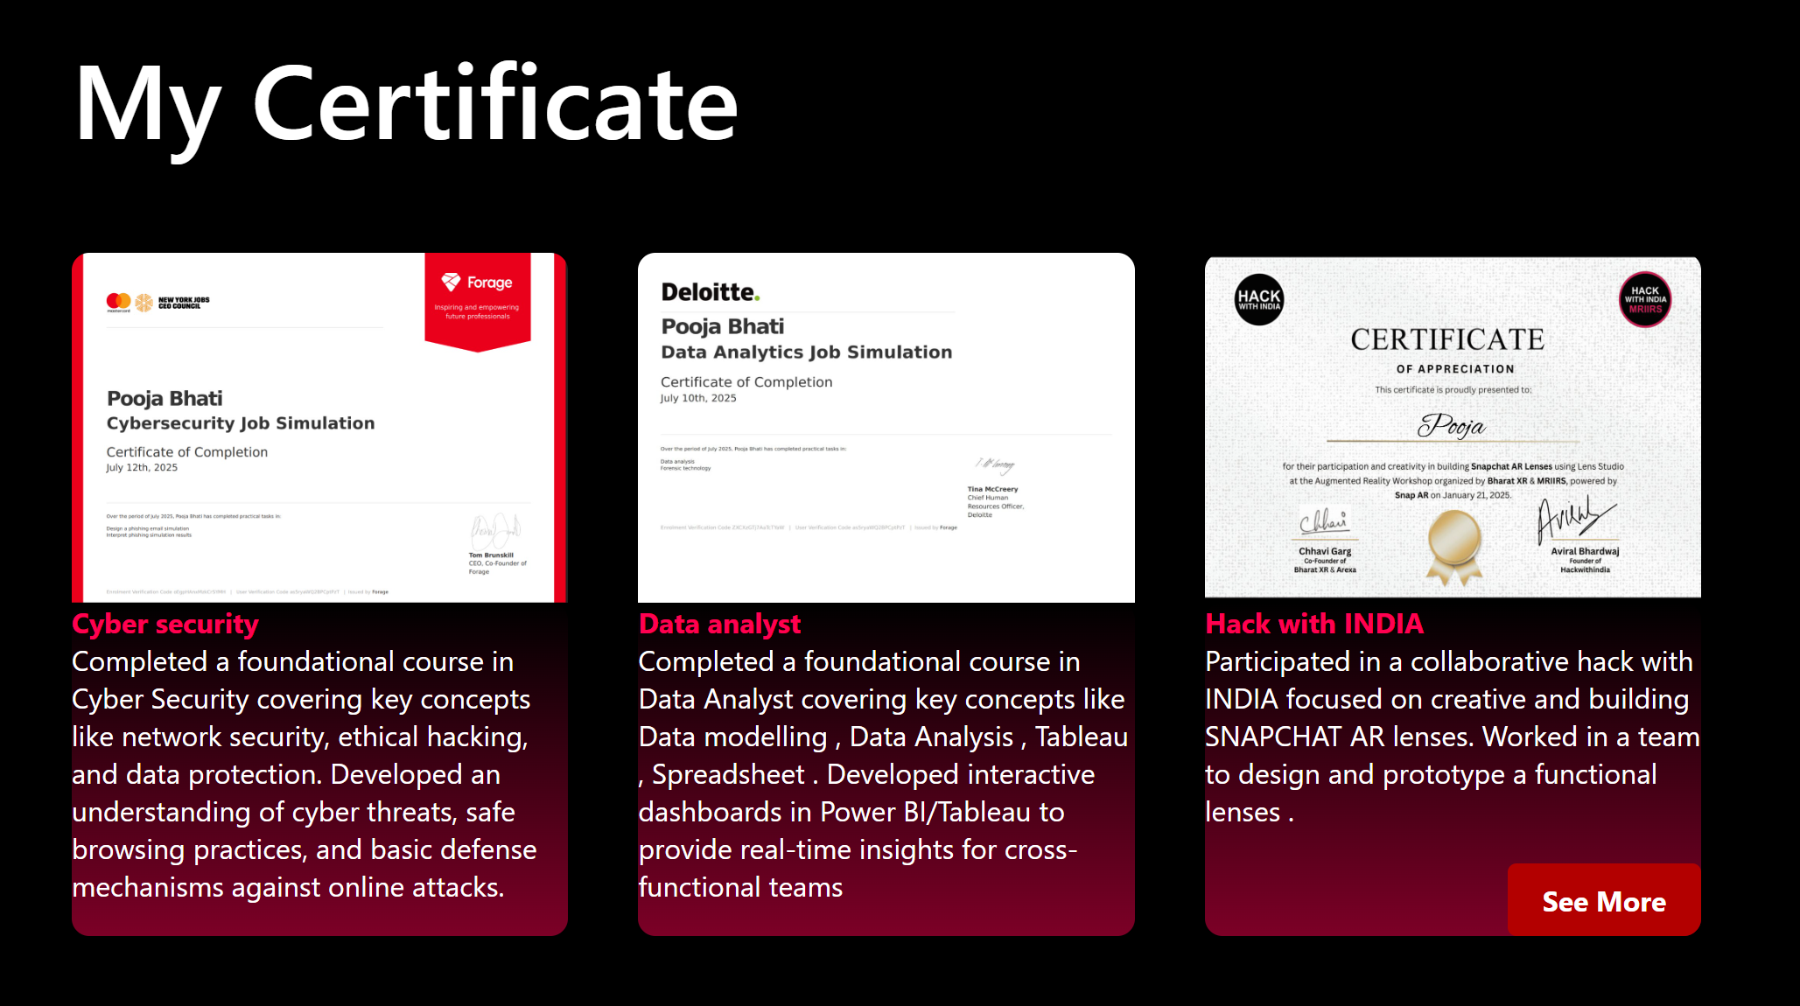

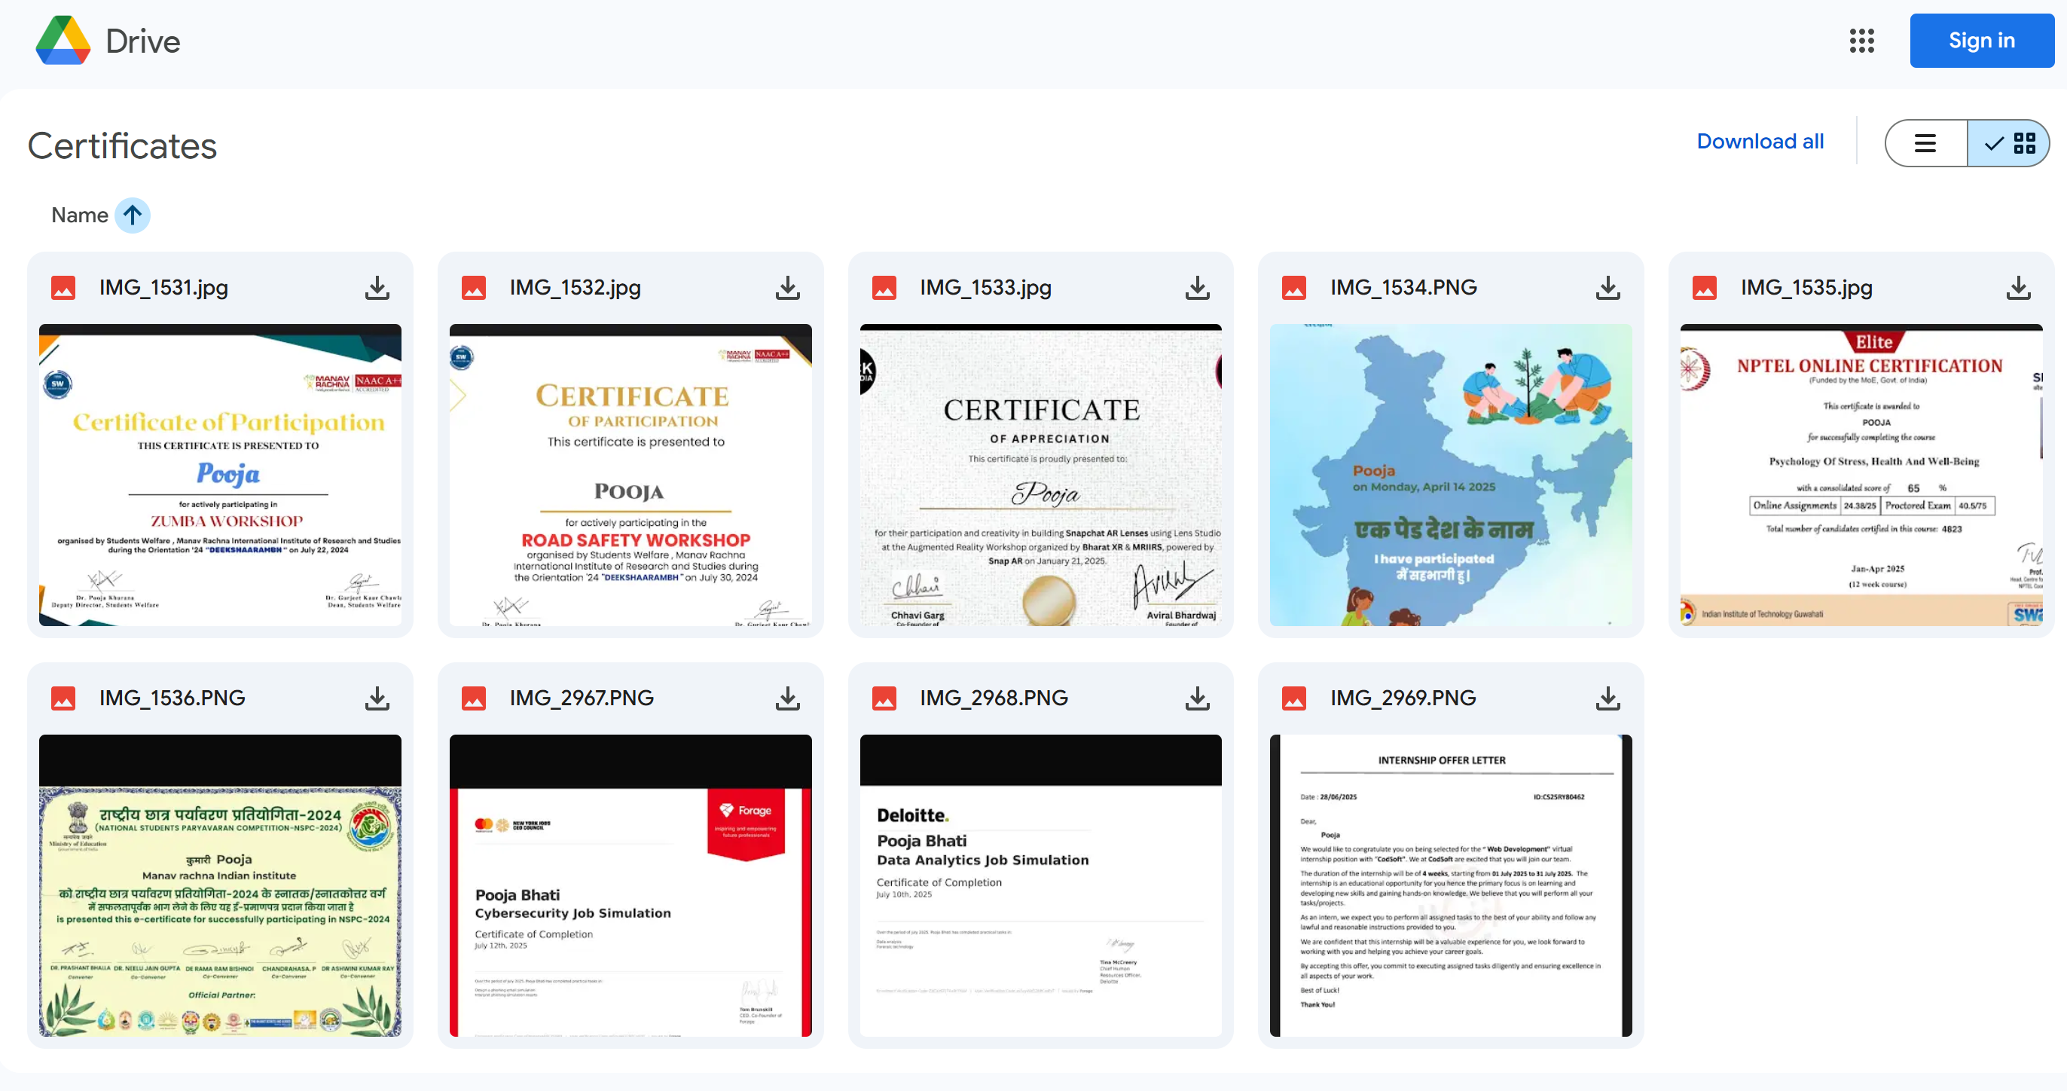
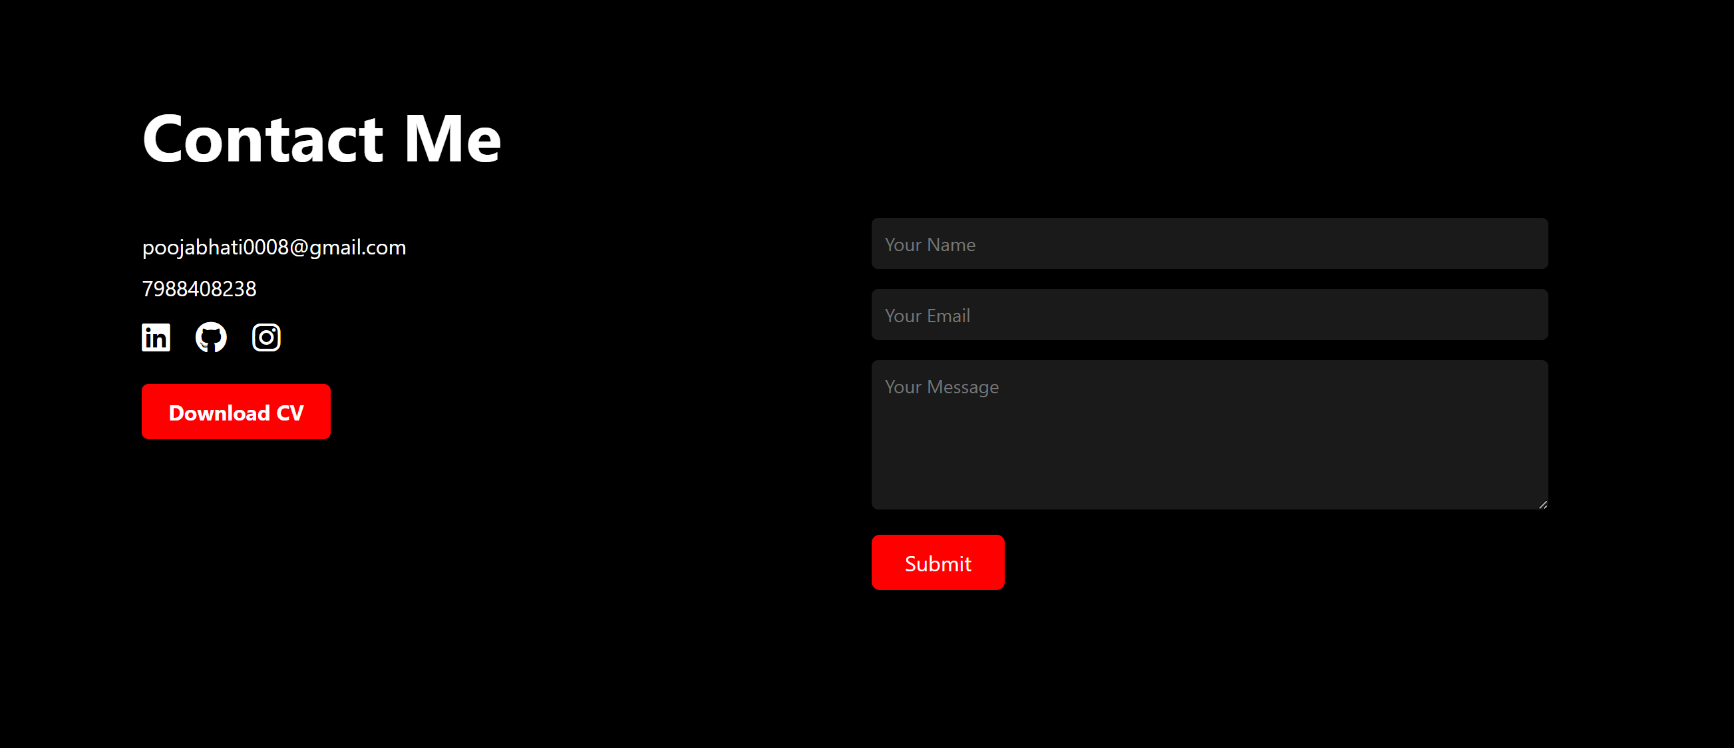
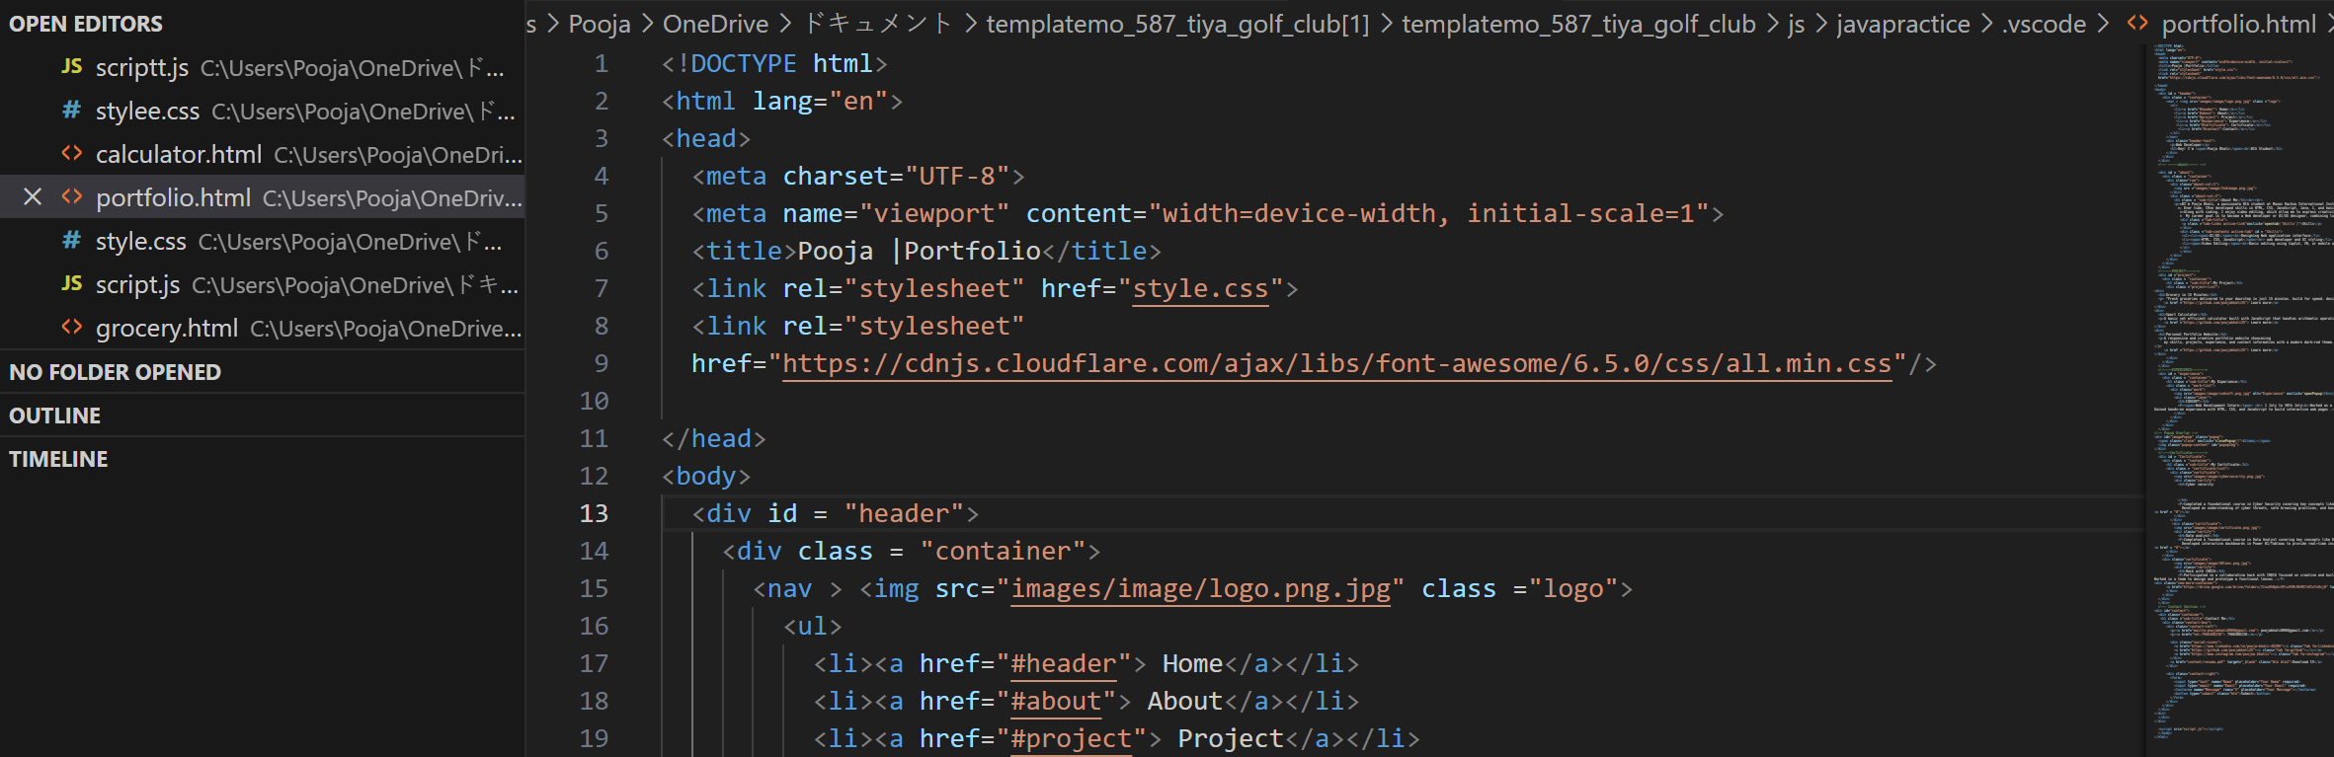

🔹 Landing Page
Existing System
Many businesses and startups rely on generic third-party templates that often fail to reflect their unique brand identity. These templates tend to be non-responsive, and lack the visual appeal required to effectively capture and retain user attention. Additionally, they frequently overlook key design principles such as layout hierarchy, navigation, and user engagement, resulting in poor user experience and limited conversion potential.

Proposed Solution
To address these issues, a custom-designed, modern single-page landing website was developed—tailored specifically to highlight a product or business offering. This solution emphasizes clean visual hierarchy, smooth user flow, and user-centric design.

Key Features of the Landing Page:
- Hero section with banner image and CTA (Call to Action)
- Feature section with icons or text blocks
- Navigation bar with smooth scrolling
- Footer with contact information and social media icons
- Optimized for mobile, tablet, and desktop

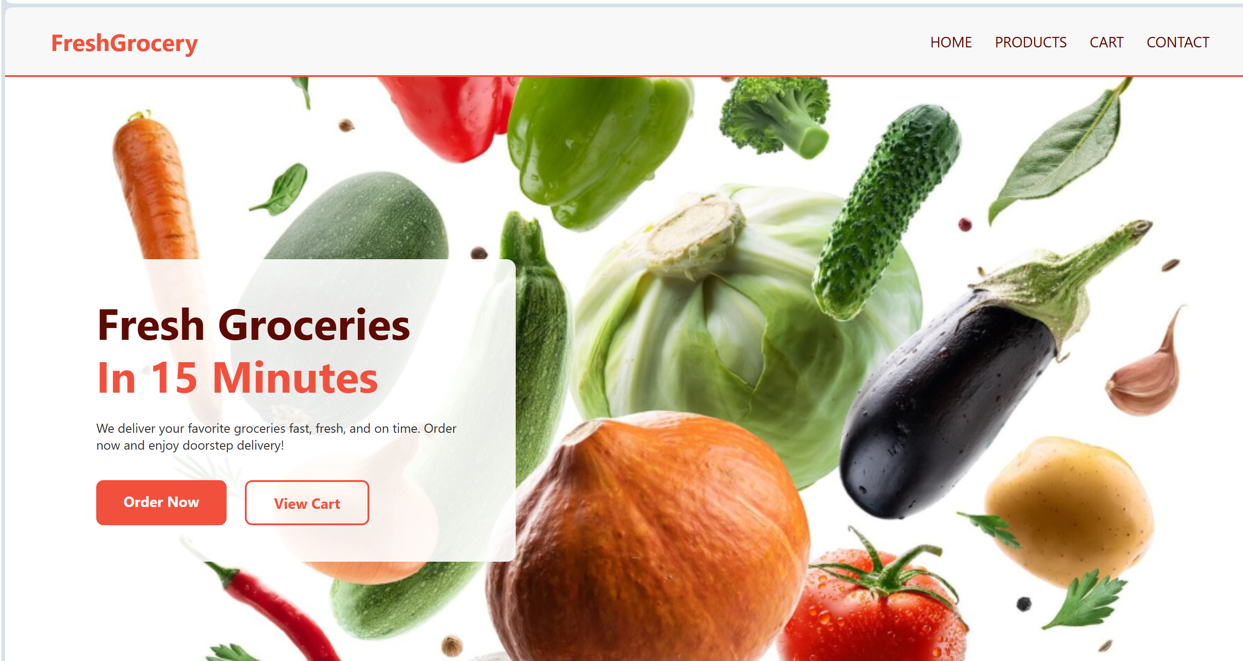
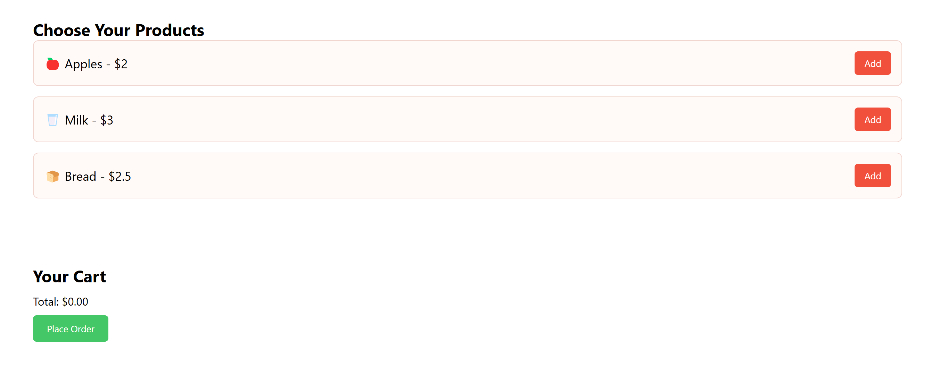
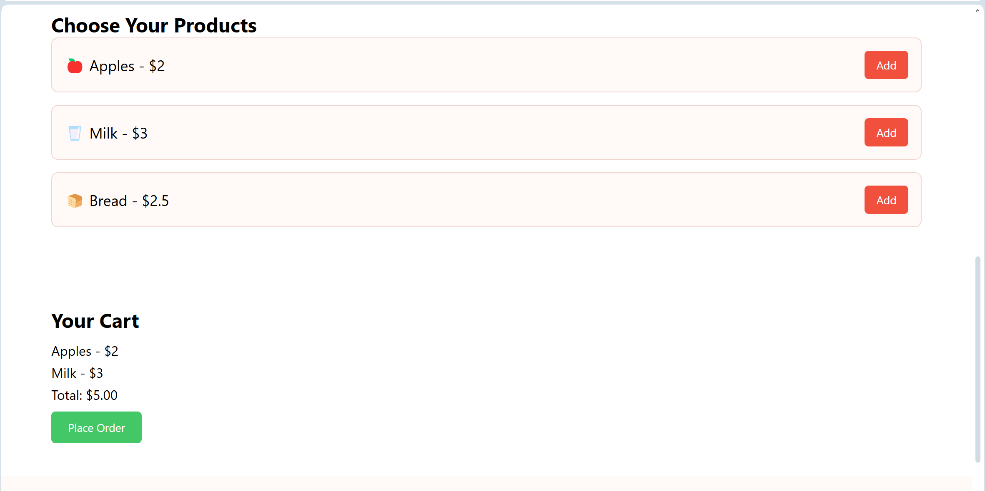
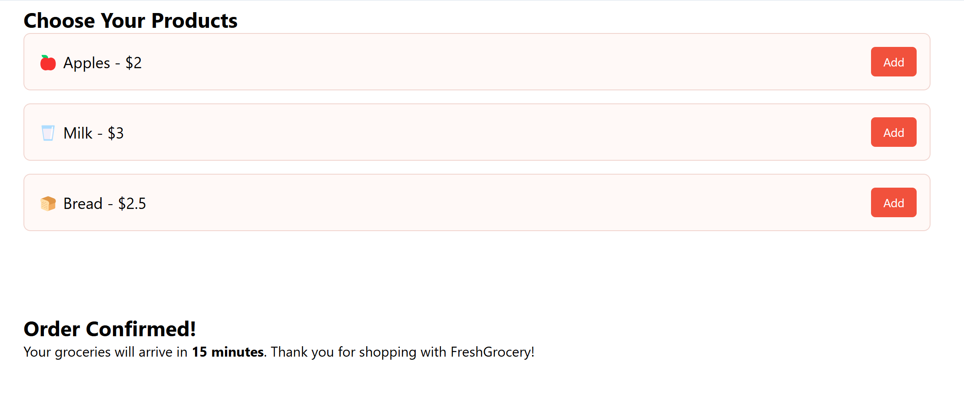
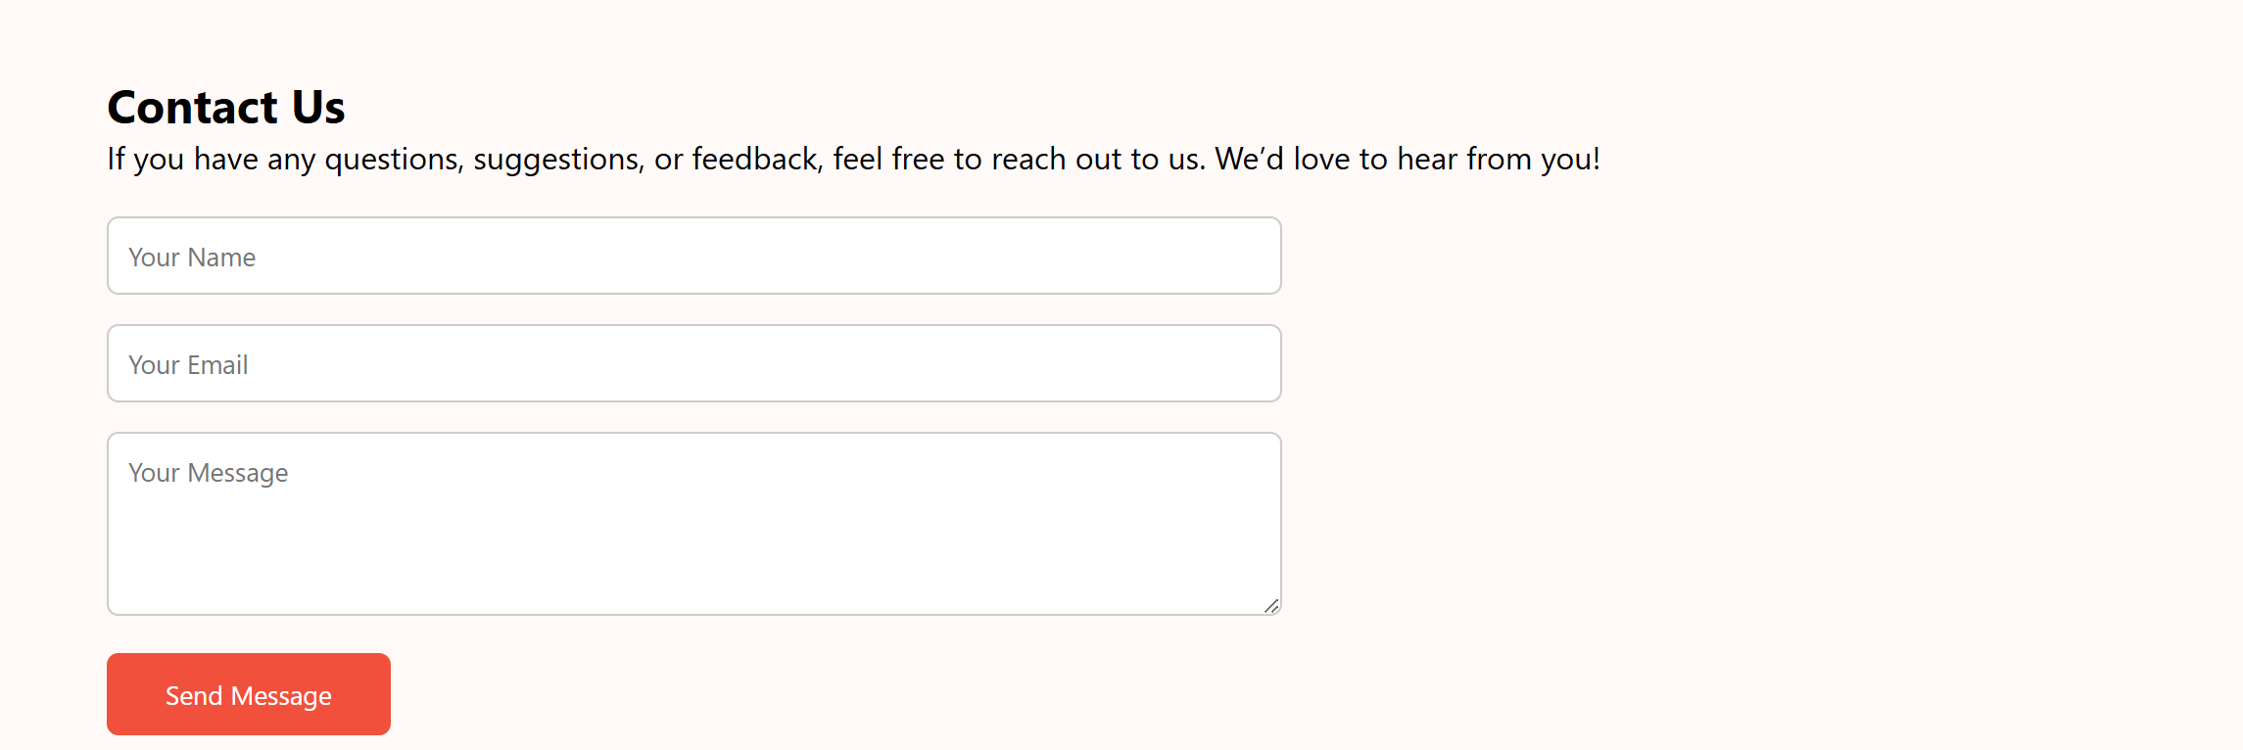
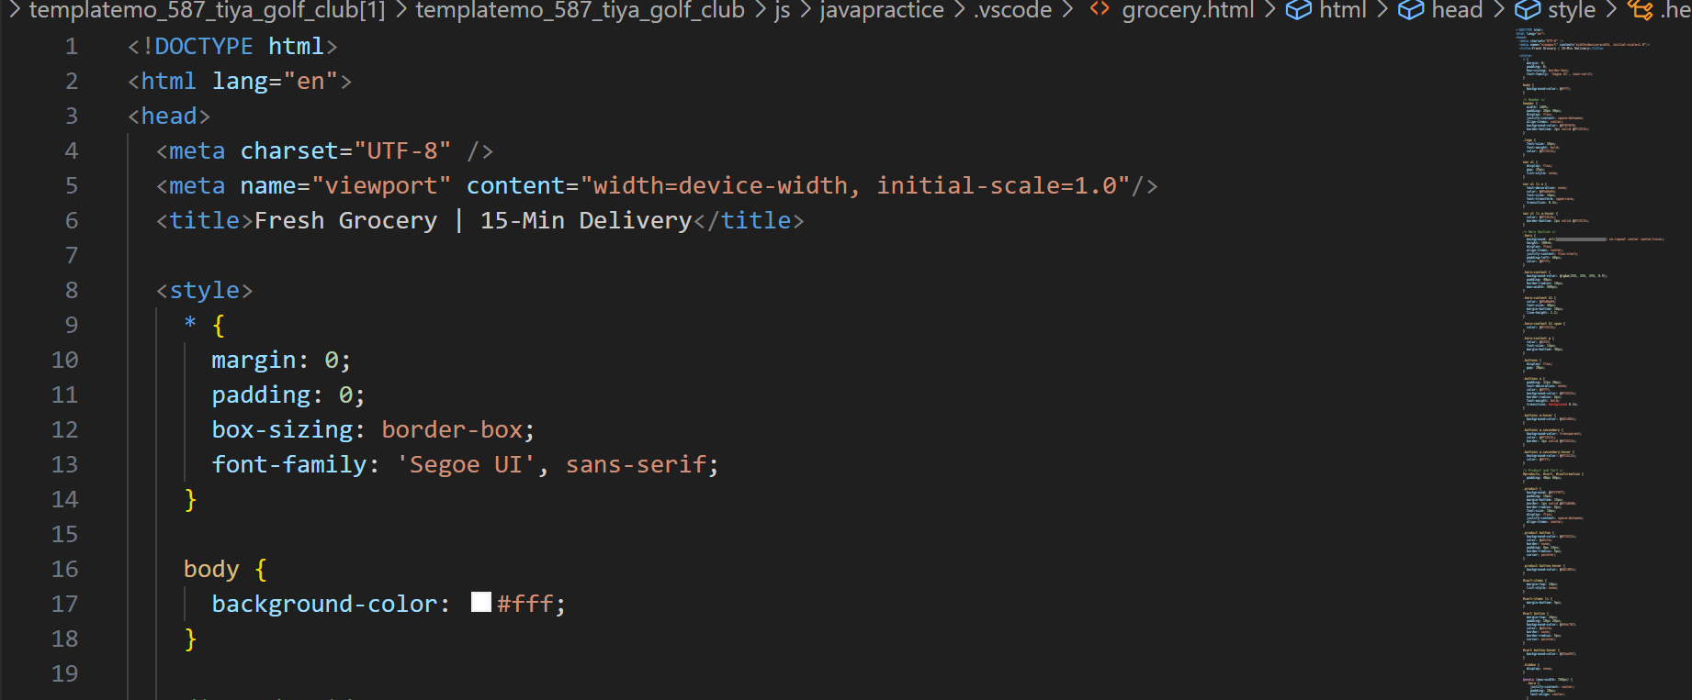

🔹 Calculator
Existing System
The majority of users depend on default calculator apps available on their smartphones or desktops.
While functional, these tools often lack personalization, visual aesthetics, and interactive user experience. There is a noticeable gap in the availability of web-based calculators that are not only responsive and user-friendly but also designed to demonstrate a developer’s technical and creative abilities through clean design and interactive features.
Proposed System
The calculator project is a browser-based solution that replicates arithmetic operations like addition, subtraction, multiplication, and division. Built using HTML, styled with CSS, and powered by JavaScript, this tool provides a simple, interactive interface.
Key Features of the Calculator:
- Responsive layout adapting to all screens
- Supports addition, subtraction, multiplication, and division
- Clear and Backspace buttons
- Styled buttons with hover animations
- Simple JavaScript logic using event listeners and equal()
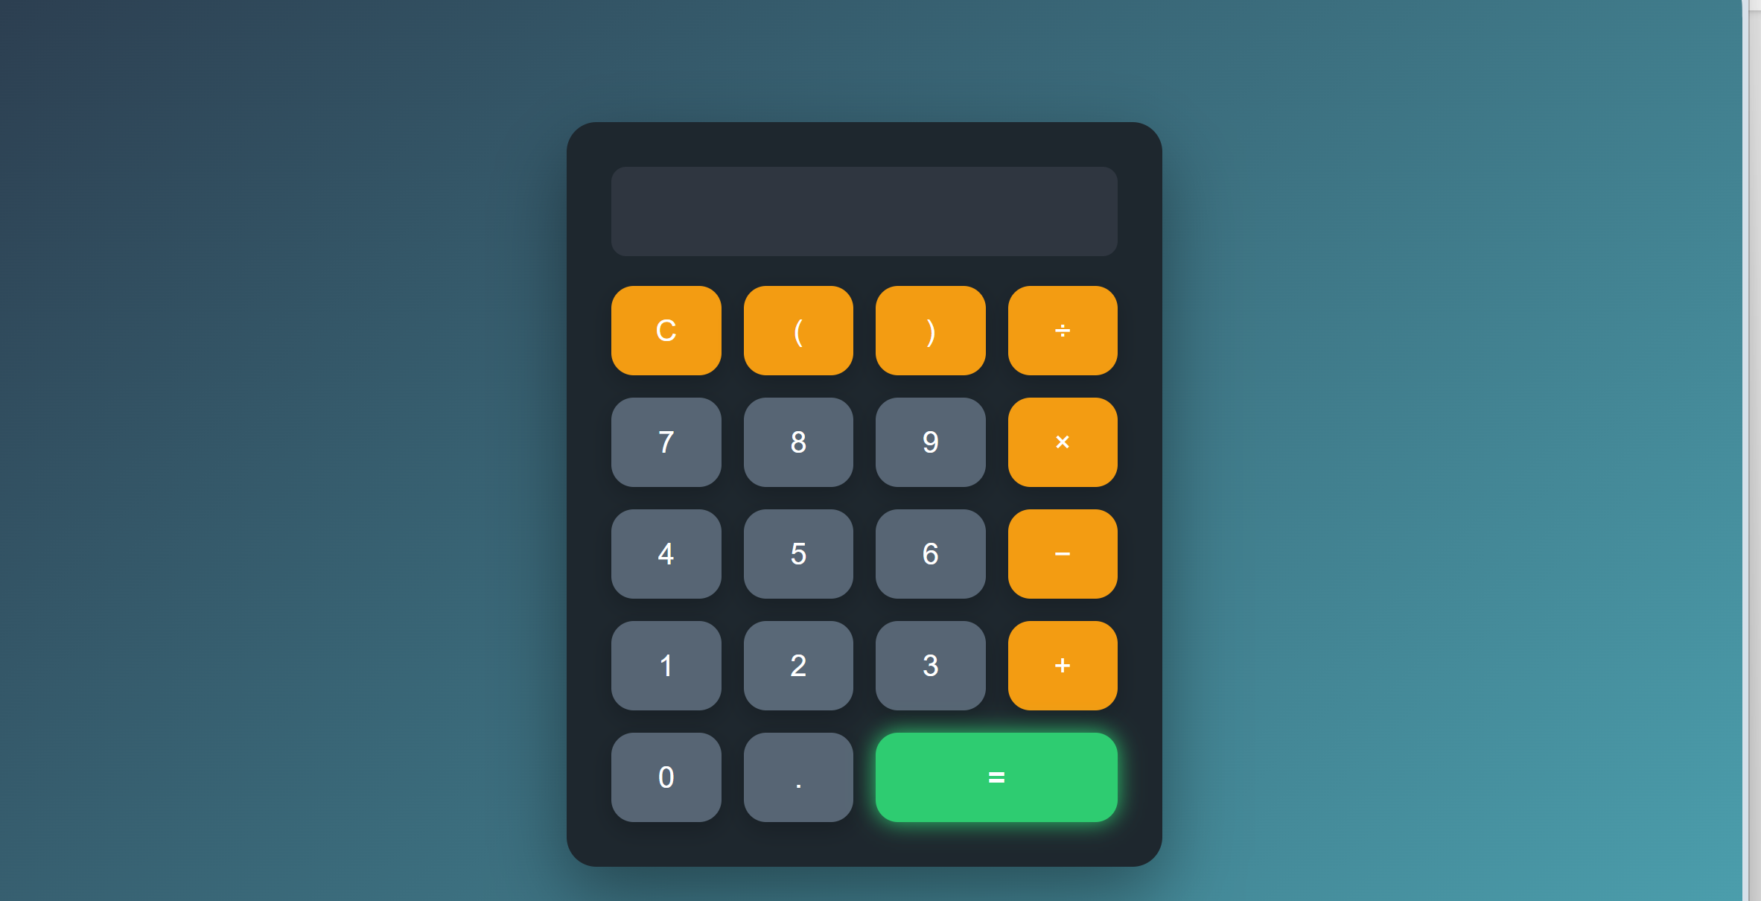
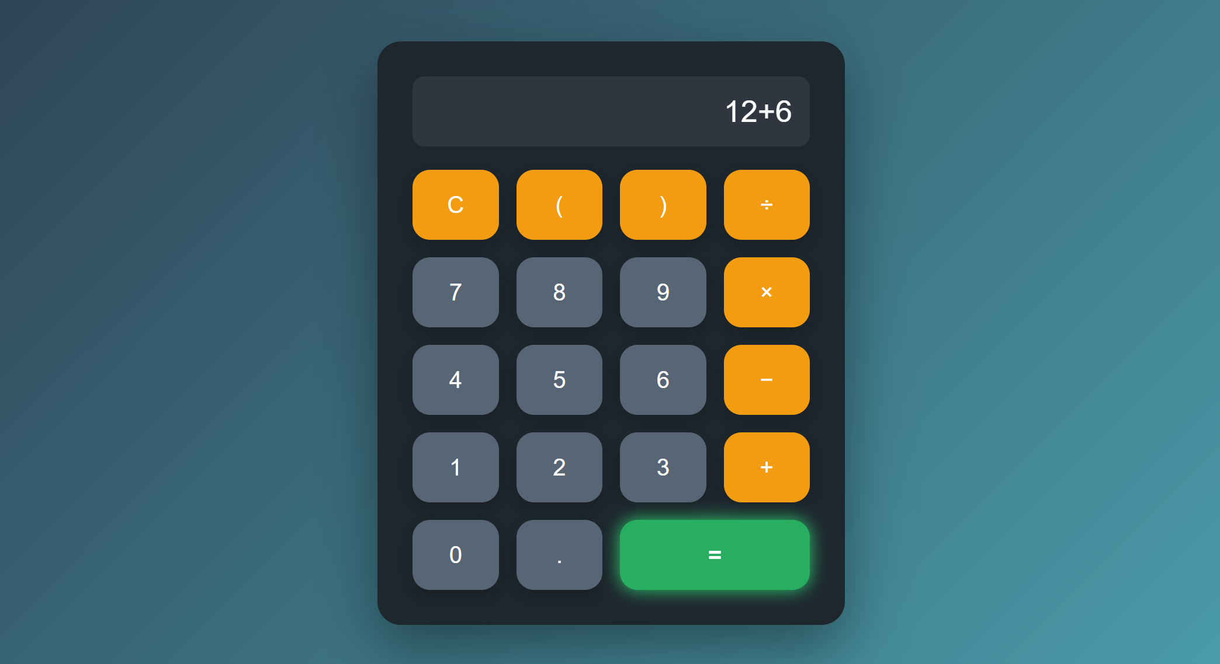
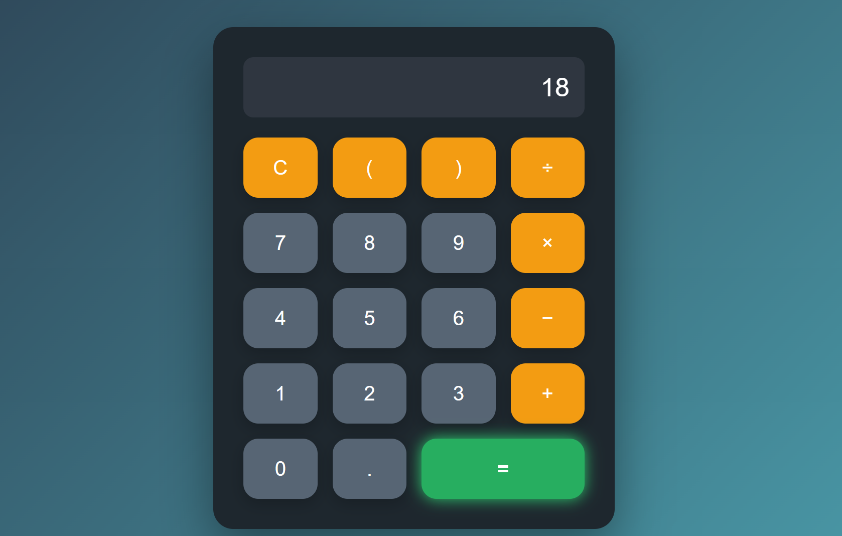
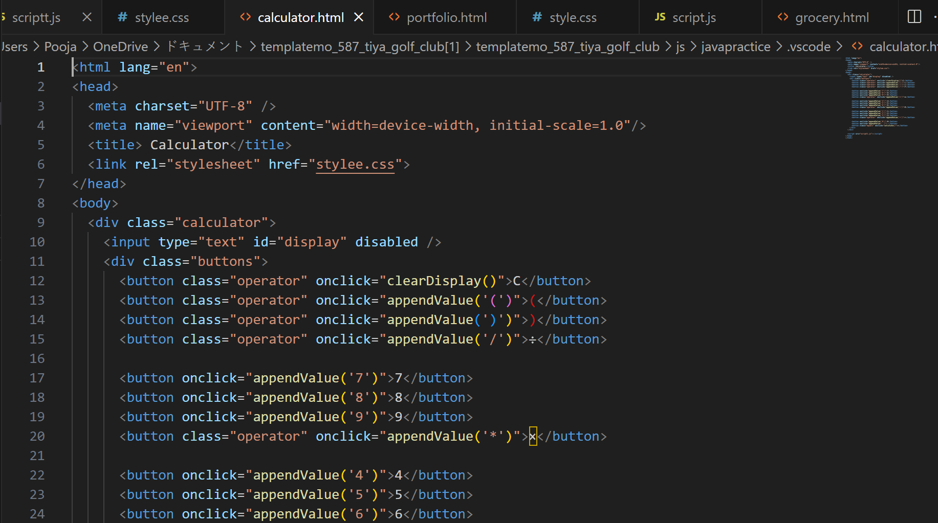
Proposed System and its Advantages
The proposed system completely revamps the outdated approach by implementing a structured, responsive, and modern web-based solution. The idea behind this system is not only to build interactive web pages but also to use this opportunity as a self-learning and self-branding exercise.
Three projects were developed during this internship:
- Portfolio Website: A personal website designed to display the developer's skills, resume, contact information, and project work in a clean and modern layout.
- Landing Page: A responsive and visually appealing business or product promotional page designed with scrolling effects and media queries.
- Calculator: A functional arithmetic calculator that performs basic operations and provides instant output through a JavaScript interface.
These projects were designed from scratch, giving full control over content structure, styling, responsiveness, interactivity, and user experience.
Detailed Benefits of the Proposed System:
- Fully Responsive Layout: Built using modern CSS techniques including media queries and flexible grid layouts, ensuring optimal display on mobile phones, tablets, and desktops.
- Improved User Experience: Use of animations, transitions, and hover effects to engage users.
- Personal Branding: A personalized portfolio allows individuals to create a web identity, which is crucial for job applications or freelancing.
- Custom CSS Styling: Leveraged advanced CSS techniques like Flexbox, Grid, animation keyframes, and pseudo-classes to enhance UI.
- Logical JS Integration: Used JavaScript for DOM manipulation, interactive navigation, form validations, and calculator logic.
- SEO & Performance Awareness: Structured HTML tags and fast-loading elements improve discoverability and performance.
- Live Hosting & Sharing: All projects were deployed using GitHub Pages, making them publicly accessible through URLs.
- Scalability & Maintenance: Modular structure allows easy updates or migration to frameworks like React.js or integration with backend systems.
- Practical Learning Outcome: Enabled comprehensive understanding of how frontend systems operate in real scenarios.

By incorporating design principles, interactive logic, and proper project structure, the proposed system not only meets the functional requirements but also enhances user satisfaction and personal learning.
The new system involves developing three independent web-based applications:
- A Personal Portfolio Website
- A Business Landing Page
- A Calculator
Each project was built from scratch using HTML, CSS, and JavaScript, keeping responsiveness, interactivity, and usability as primary goals. These solutions were designed with real-world usage in mind and can be further extended into professional deployments.

Advantages of the Proposed System:
Device Responsiveness
- The layout seamlessly adapts across all screen sizes—mobile, tablet, and desktop—using CSS media queries, ensuring a consistent and accessible user experience.

2. Improved Visual Experience
- Enhanced UI/UX is achieved through the use of custom transitions, scroll animations, and hover effects implemented via CSS and JavaScript, making the interface visually engaging and smooth.

3. High Customizability
- Each component is designed with flexibility in mind, making it easy to update content, modify styles, or expand features without reworking the entire structure.

4. Modular & Reusable Code
- The project follows a clean and modular code structure, allowing core elements and functions to be reused in future web development projects with minimal adjustments.

5. Interactive User Engagement
- Interactive buttons, visual feedback on clicks, and subtle hover animations enhance the overall engagement and encourage user interaction with the content.

6. Future Scalability
- Built with scalability in mind, the system can be extended using modern frameworks like React, styled with Bootstrap, or connected with backend technologies for full-stack development.

7. Educational Value
- This project served as a practical learning experience, strengthening the understanding of HTML, CSS, JavaScript, and GitHub integration while following real-world development practices.

8. Live Deployment
- The final version was deployed on GitHub Pages, making the project publicly accessible and shareable as a part of an online portfolio or resume.

This modernized system ensures a better user experience, offers a dynamic interface, and most importantly, serves as a digital proof of my web development capabilities.

FEASIBILITY STUDY
Feasibility study is a crucial stage in any project development cycle. It assesses whether the proposed solution is practical and achievable within the given constraints—such as technology, user behaviour, cost, timeline, and available resources. For the internship projects—Portfolio Website, Web-based Calculator, and Product Landing Page—a detailed feasibility analysis was conducted prior to initiating the development process to ensure efficiency and success.

1. Technical Feasibility
The proposed projects were built using lightweight and widely-supported web technologies—HTML5, CSS3, and JavaScript. These technologies are open-source, platform-independent, and do not require high-end hardware or proprietary software. They ensure compatibility across all modern browsers and operating systems, allowing the applications to run efficiently on desktops, laptops, tablets, and mobile devices without performance limitations.

Tools & Technologies Used:
Tool/Technology | Purpose
HTML5 | Web page structure
CSS3 | Styling and layout
JavaScript | Interactivity and functionality
Visual Studio Code | Code editor
Google Chrome | Live testing and debugging
GitHub | Version control and optional hosting

Justification:
- No backend or databases required.
- Cross-browser compatible.
- Lightweight, fast, and modern tools.
- No installation of frameworks like React or Angular necessary.
Conclusion:
All three projects are technically feasible using readily available and widely supported tools.
2. Behavioral / Operational Feasibility
The projects were designed with a strong emphasis on user experience (UX) and interface usability. Each system was tested across devices to ensure that the design was not only functional but intuitive for users with minimal technical skills.
- Portfolio Website:
- Navigation bar enables smooth transitions between sections.
- Responsive layout ensures mobile, tablet, and desktop compatibility.
- Contact form with input validation enhances user trust.
- Calculator:
- Immediate input feedback and live calculation response.
- Clear and backspace buttons increase usability.
- Suitable for all age groups and education levels.
- Landing Page:
- Scroll-friendly layout with CTA (Call-To-Action) buttons.
- Balanced use of images, text, and icons.
- Designed for first-time visitors and potential customers.

3. Economic Feasibility
One of the most critical advantages of this internship project was that it incurred zero monetary cost. All development tools used were free, and the entire project could be built on a personal laptop without additional hardware/software investment.

- Cost Estimation:
Resource | Cost (INR) | Notes
Visual Studio Code | ₹0 | Free download
Chrome Browser | ₹0 | Pre-installed or freely available
GitHub Account | ₹0 | Optional cloud hosting
HTML/CSS/JS | ₹0 | No licensing required
Images/Icons | ₹0 | Used royalty-free assets
Total Cost | ₹0 | Completely cost-efficient

Developed Time:
Project | Estimated Time | Total Working Days
Portfolio Website | 4-5 Days | Week 1
Calculator | 2-3 Days | Between week 1 & week 2
Landing Page | 4–5 Days | Week 2
Documentation | 4-5 Days | Week 3

Gantt Chart: Project Timeline Overview
To manage the internship efficiently, a task-based weekly schedule was followed. The timeline below shows how work was planned and executed throughout the internship from 1 July 2025 to 30 July 2025.
Week | Dates | Task | Descriptions
1 | 1-5 July 2025 | Portfolio Website development | Designed and developed a responsive portfolio website
2 | 5–8 July 2025 | Calculator design and functionality | Built a JavaScript calculator with styling and logic
3 | 8-13 June 2025 | Landing Page layout and structure | Created a landing page with call-to-action flow
4 | 5–11 July 2025 | Documentation and Screenshot capture | Wrote report sections and prepared screenshots
5 | 8–15 July 2025 | Final testing and submission | Reviewed, refined code, and finalized project files

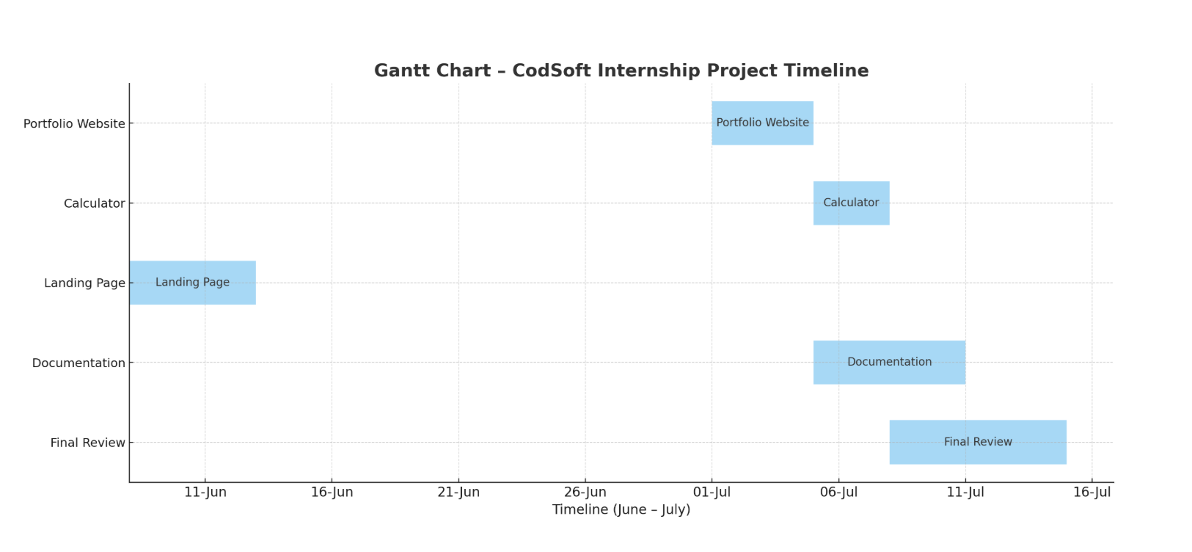
Figure: Gantt Chart Representing Internship Task Timeline (June – July 2025)

SYSTEM ANALYSIS
System analysis is a crucial part of software development that involves studying the current systems, identifying the requirements, and determining how the system should function to fulfill those requirements. During the internship, three projects were developed—Portfolio Website, Calculator, and Landing Page—each having specific functional and non-functional requirements.
Requirement Specification
- Functional Requirements
These define the expected functionalities of the system based on user interactions and project objectives.
Project | Functional Features
Portfolio Website | Navigate to sections (Home, About, Skills, Projects, Contact) with a functional contact form
Calculator | Input numbers and operators, display result instantly, clear/reset and backspace functionality
Landing Page | Scroll to sections, click CTA buttons, display product or service content, mobile-friendly layout

- Non-Functional Requirements
These define the quality attributes and system performance constraints:
- Performance: Each system should load quickly in under 2 seconds and respond to interactions in real-time.
- Responsiveness: The UI must be fully responsive across smartphones, tablets, and desktops.
- Usability: Easy navigation and intuitive interface, even for first-time users.
- Accessibility: Clear font styles, proper contrast, and keyboard navigation for inclusive design.
- Maintainability: Clean, modular code with meaningful comments, consistent indentation, and reusability.
- Portability: Should work consistently across all modern browsers like Chrome, Firefox, and Edge

System Flowcharts
Each project was visualized with simple flow diagrams to represent how users interact with the systems.
- Portfolio Website Flowchart:

Start
↓
Homepage Loads
↓
User Navigates to Sections (Home, About, Skills, Projects, Contact)
↓
(Optional) User Fills Contact Form
↓
End

- Landing Page Flowchart:
Start
↓
Page Loads in Browser
↓
User Scrolls to Various Sections (Features – etc.)
↓
User Clicks CTA (e.g., “Subscribe” or “Learn More”)
↓
(Optional) Form Submission / Redirect to External Link
↓
End

- Calculator Flowchart:

Start
↓

User Clicks Buttons (1–9, +, -, =, etc.)
↓

Input is Shown on Display
↓

User Presses '='
↓

JavaScript Calculates the Result
↓

Result is Displayed
↓

User Clears/Deletes Input
↓

End

DFDs (Data Flow Diagrams)

Basic DFDs were designed for understanding the data interaction and logical flow, especially in the Calculator project.

- DFD – Level 0 (Calculator)

[User] → (Calculator System) → [Result Display]

- DFD – Level 1 (Calculator Operation)

User Input
↓
Validate Input Format
↓
JavaScript Calculation Engine
↓
Perform Arithmetic Operation
↓
Display Result

SYSTEM DESIGN
  - File & Folder Structure:
Each project followed a structured folder layout for maintainability and scalability. Here's a general structure:

- Portfolio Project:

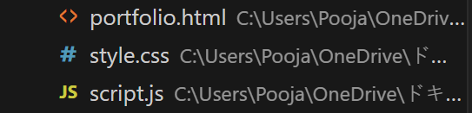

- Landing Page
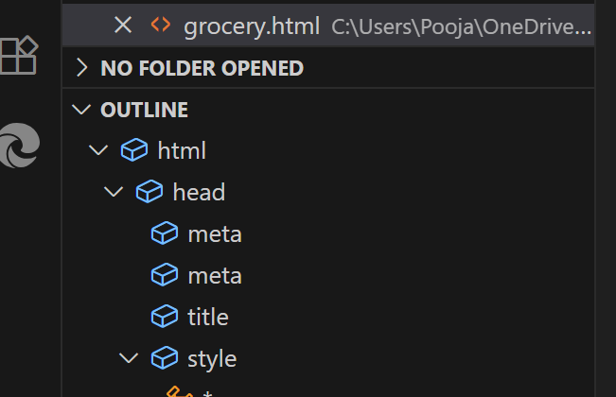

- Calculator
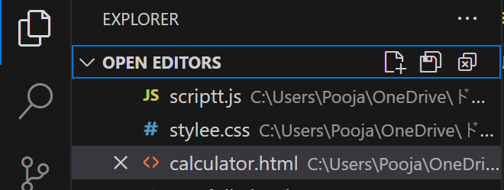

  - HTML File Design Overview:
Each project starts with a structured HTML layout that uses semantic tags and external file linking.
<!DOCTYPE html>
<html lang="en">
<head>
<meta charset="UTF-8" />
<meta name="viewport" content="width=device-width, initial-scale=1.0" />
<title>Project Title</title>
<link rel="stylesheet" href="style.css" />
</head>
<body>
<!-- Page content here -->
</body>
</html>

🔹 Tags Used:
- <header>, <nav>, <main>, <section>, <footer> for structure
- <form>, <input>, <button>, <textarea> for interactivity
- <div>, <span>, <img>, <a> for layout and content
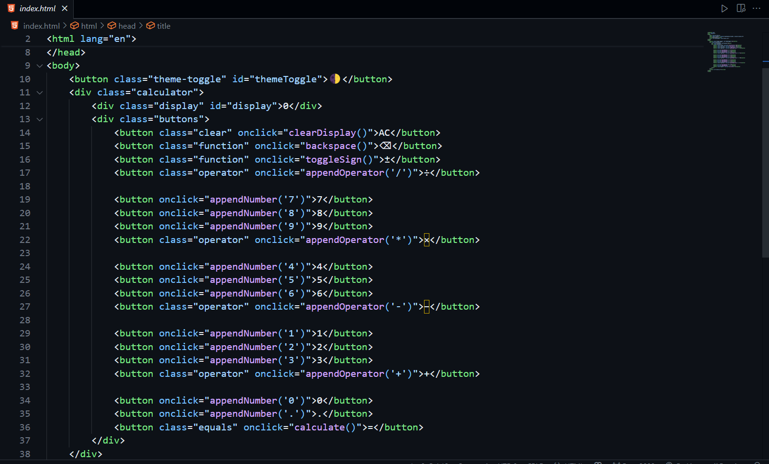

CSS Design Highlights
Each CSS file is well-organized using the following components:
- Reset styles
- Layout containers
- Typography styling
- Buttons and hover effects
- Media queries for responsiveness

Example CSS Snippet:

body {
margin: 0;
font-family: 'Poppins', sans-serif;
background-color: #f4f4f4;
}

.container {
width: 90%;
margin: auto;
padding: 20px;
}
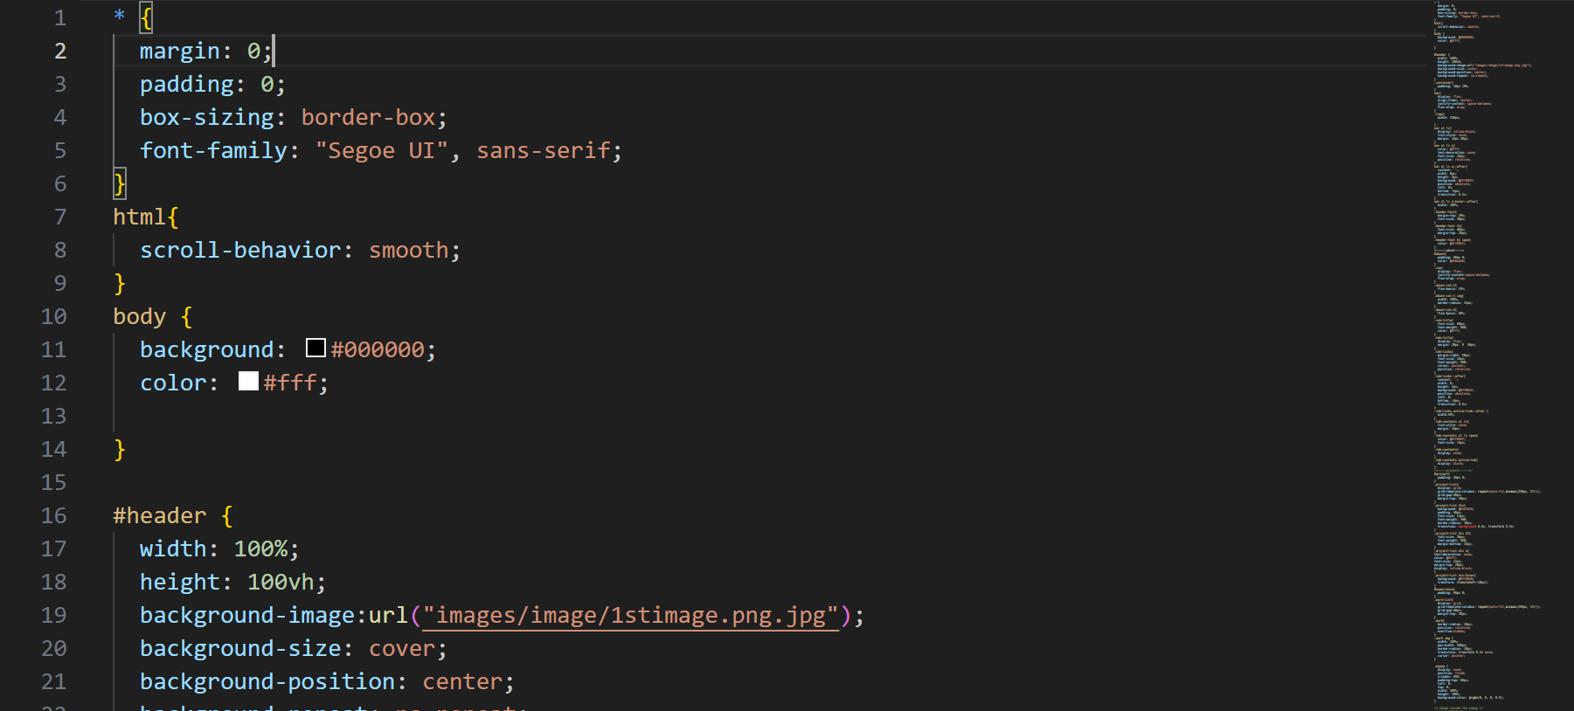

JavaScript Logic

For the calculator project, all arithmetic logic was handled in script.js.

JS Logic Includes:

- Fetching DOM elements
- Adding event listeners
- Evaluating expressions using eval()
- Clear and backspace button handling

let result = document.getElementById("result");

function appendValue(val) {
result.value += val;
}

function calculate() {
result.value = eval(result.value);
}

function clearScreen() {
result.value = "";
}

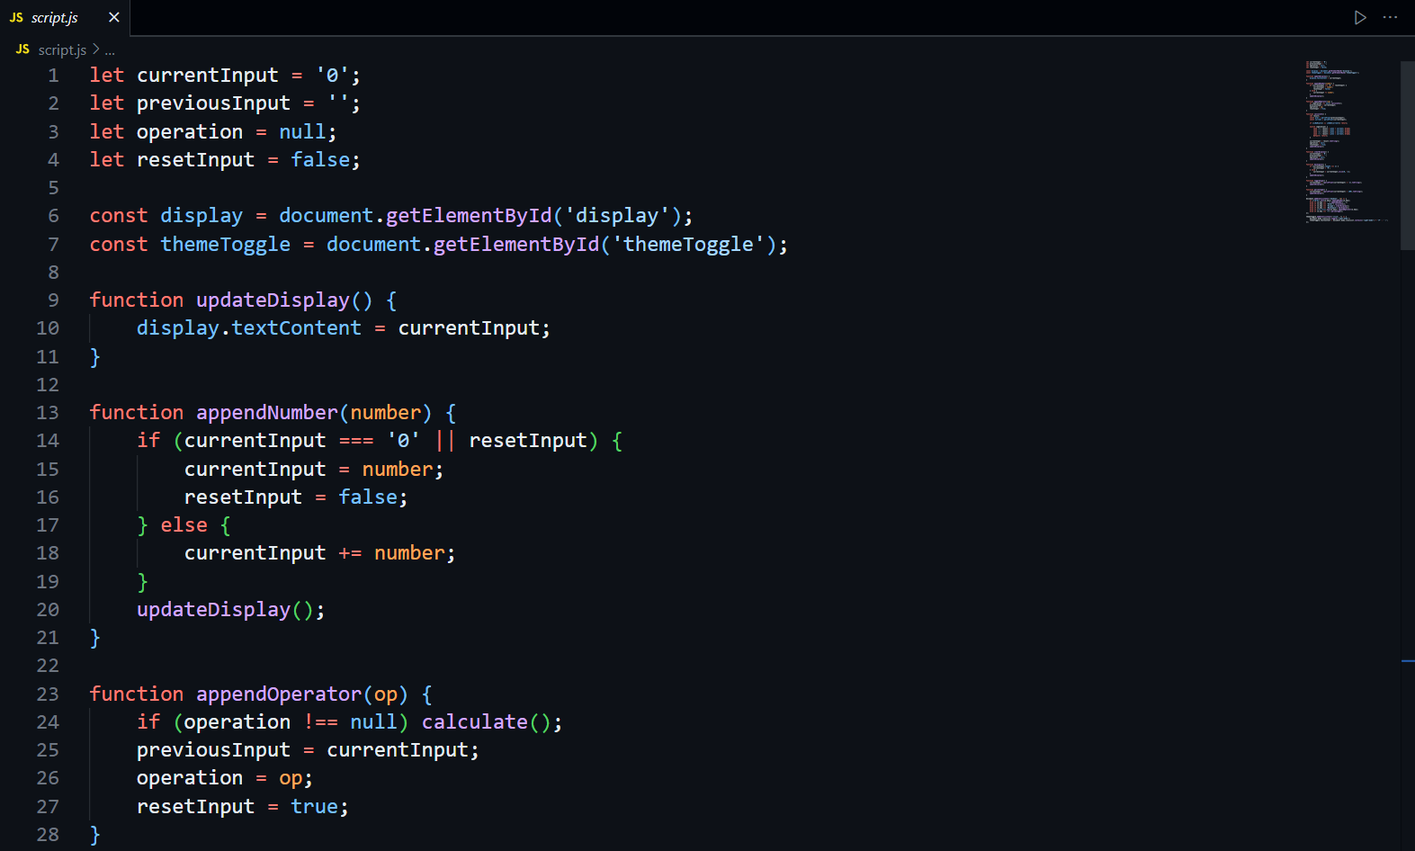

5.Navigation & Layout Design
Each project included a thoughtfully planned UI layout to ensure accessibility, user engagement, and modern aesthetics.

🔹 Portfolio Website:
- Sticky navigation bar
- Skills section using progress bars or animated icons
- Projects grid with hover animations
- Contact form with validation
🔹 Landing Page:
- Hero section with CTA (Call-to-Action)
- Feature section with icon layout
- Footer with social links and contact info
🔹 Calculator:
- Central display screen
- Button grid for digits and operations
- Responsive layout using grid/flexbox
- Mobile optimization

INPUT / OUTPUT FORM DESIGN
Input/output design defines how users interact with the system and how the system responds. This section describes the design of input forms, buttons, layout interactions, and visible outputs generated through HTML, CSS, and JavaScript.
The goal was to ensure user-friendly forms, responsive buttons, and intuitive design across all three projects.
1. Portfolio Website – Input / Output Design
🔹 Input Form: Contact Section
The portfolio includes a contact form where visitors can enter their details and send a message.
Form Fields:
- Name (Text Input)
- Email (Text Input with HTML5 Validation)
- Message (Textarea)
- Submit Button
Html Code S:
<form>
<input type="text" placeholder="Your Name" required>
<input type="email" placeholder="Your Email" required>
<textarea placeholder="Your Message"></textarea>
<button type="submit">Send</button>
</form>
Output Display:
- Displays a confirmation message upon submission.
- Input fields highlight errors if empty or invalid.
- Simple hover animations and transitions.
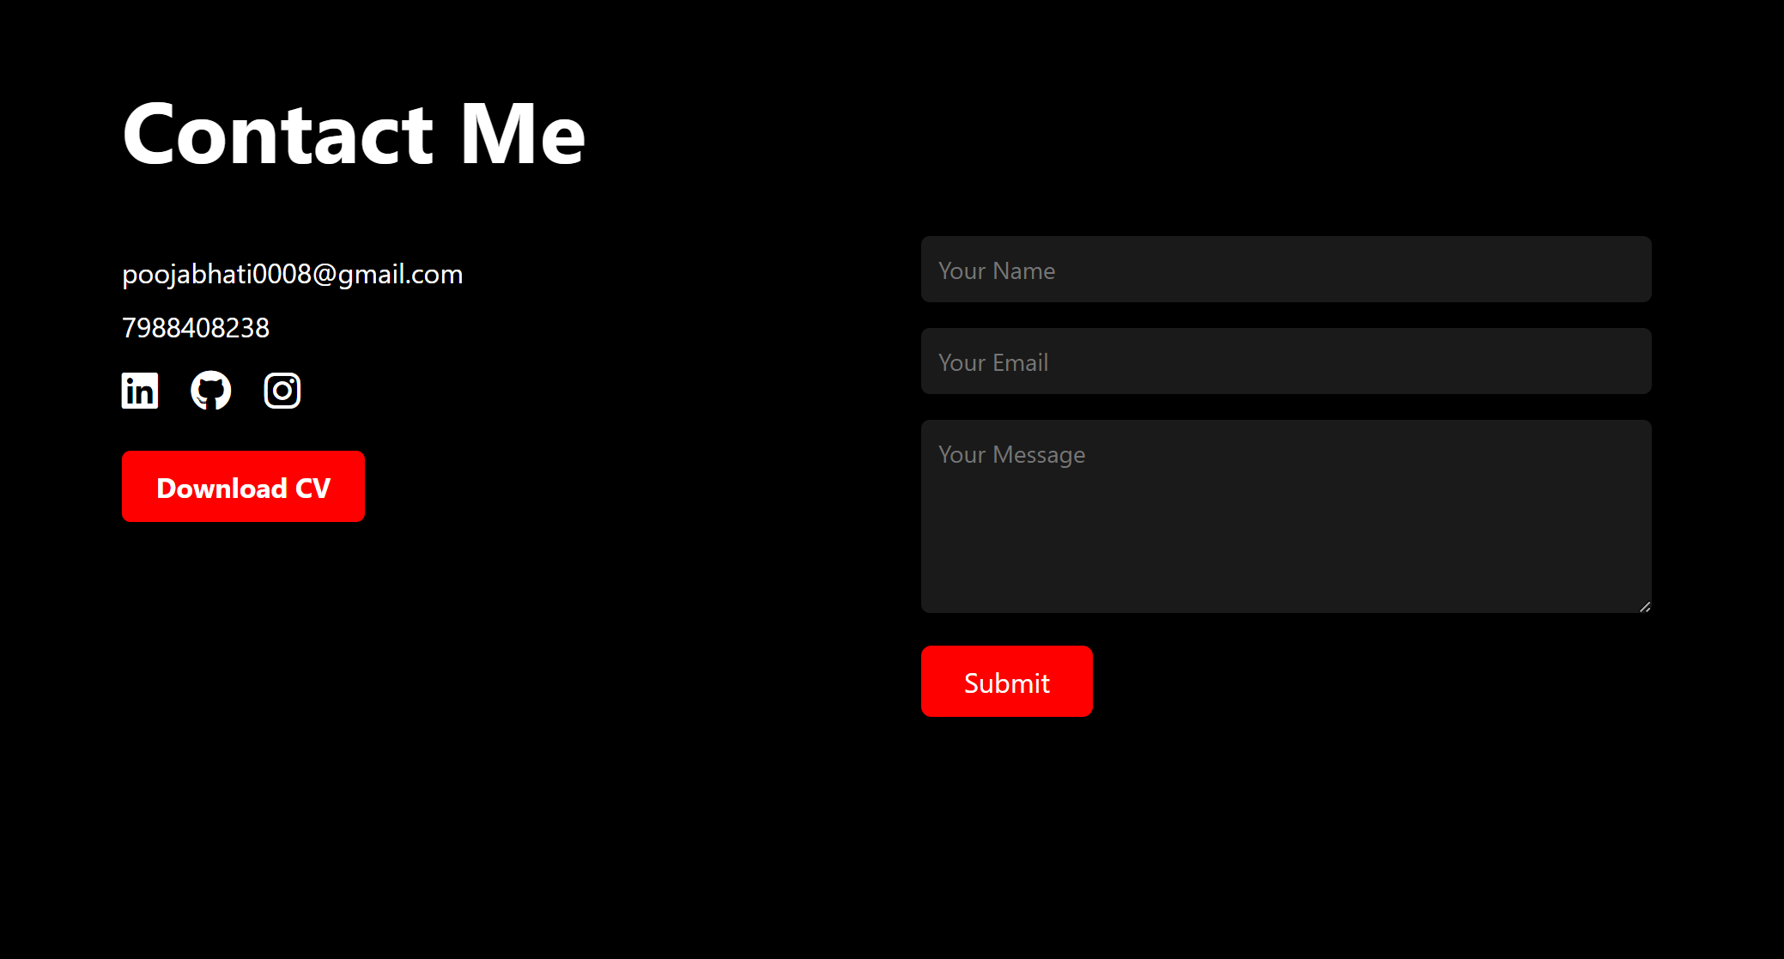

2. Landing Page – Input / Output Design

Landing page may include a newsletter form, call-to-action buttons, or navigation links that act as inputs.
🔹 Input Form Example: Newsletter Subscription

html
CopyEdit
<form>
<input type="email" placeholder="Enter your email" required>
<button type="submit">Subscribe</button>
</form>
🔹 Output Display:
- Scroll animation or smooth transition.
- (Optional) Alert: “Thank you for subscribing!”
- Change in visual layout or redirected section.
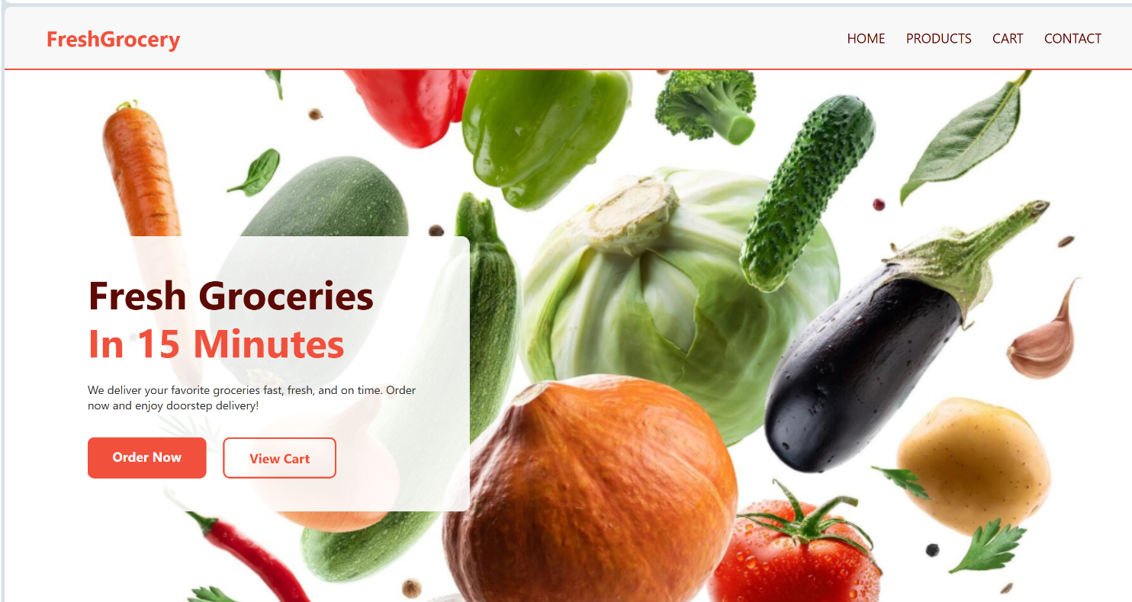
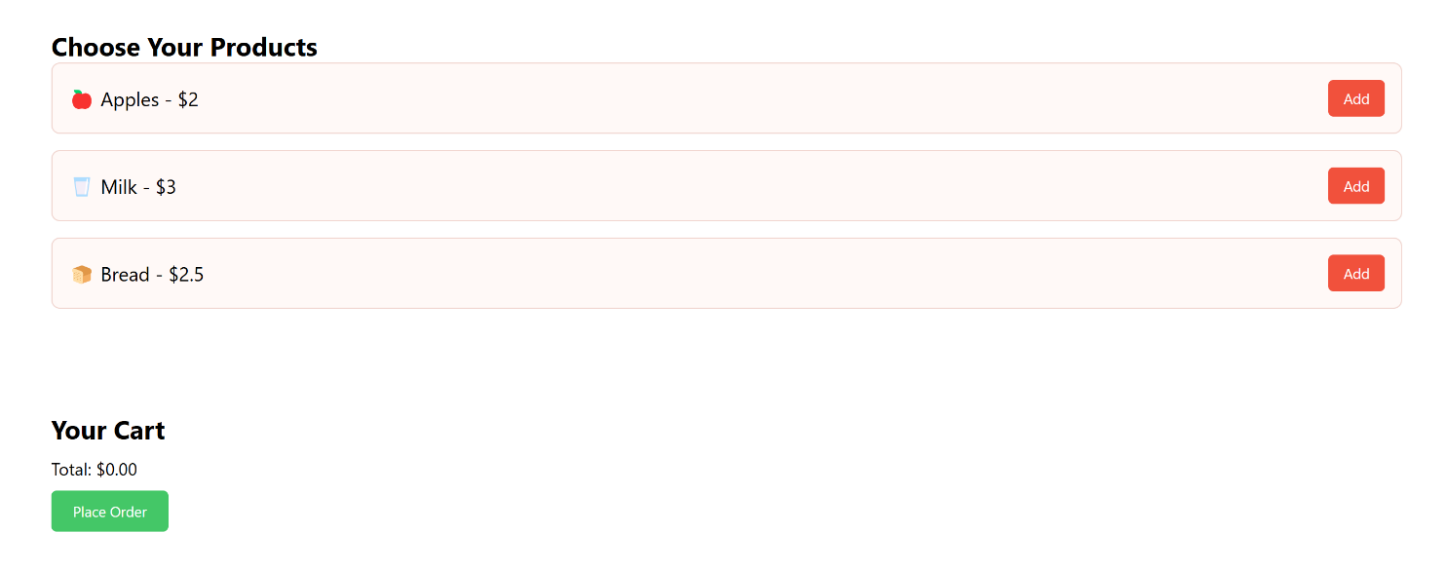

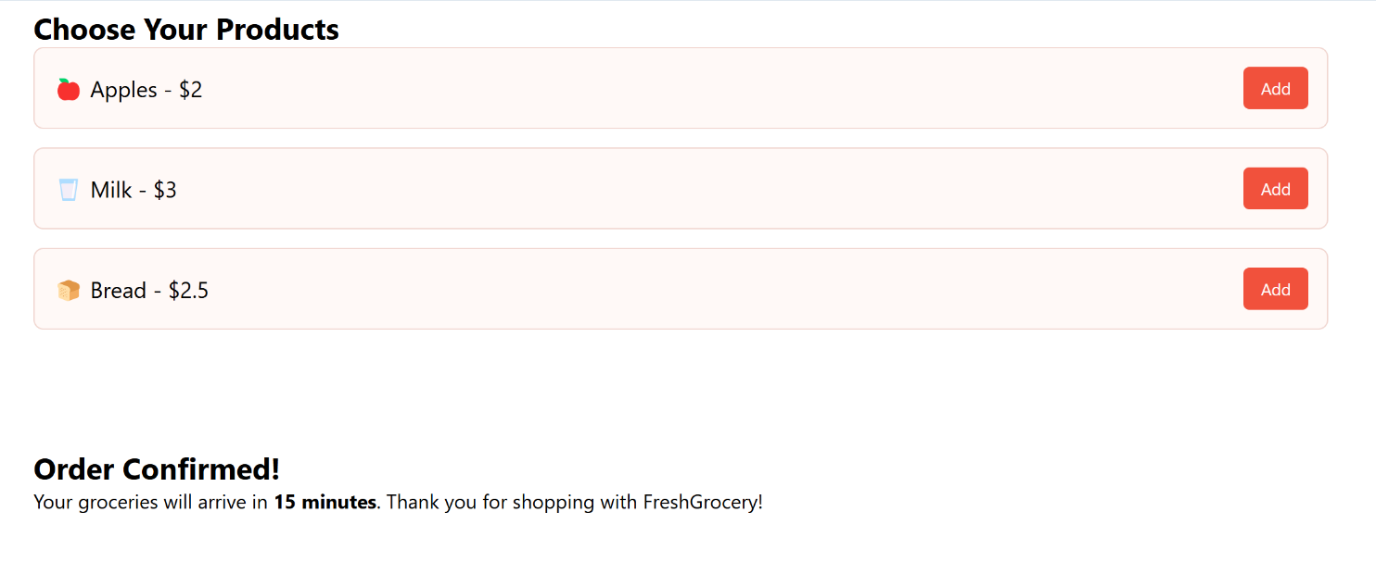
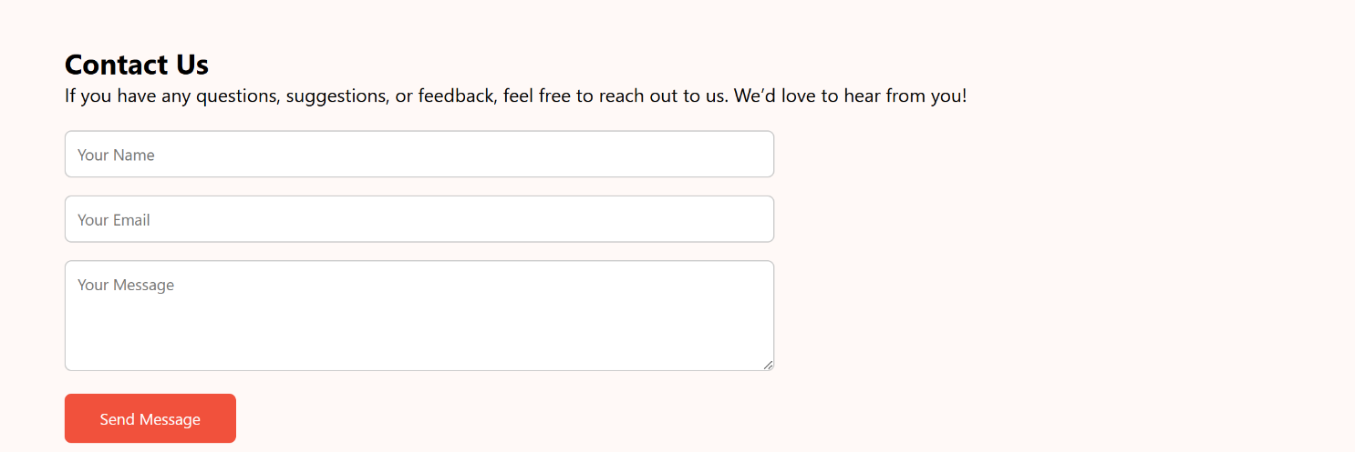

2. Calculator – Input / Output Design
The calculator accepts user input through on-screen buttons and outputs the result in a display field.
🔹 Input Mechanism:
- Number Buttons (0–9)
- Operator Buttons (+, −, ×, ÷)
- Special Buttons: =, AC, ←, ±

HTML Code Snippet:
<input type="text" id="result" readonly>
<button onclick="appendValue('1')">1</button>
<button onclick="appendValue('+')">+</button>
<button onclick="calculate()">=</button>
<button onclick="clearScreen()">AC</button>
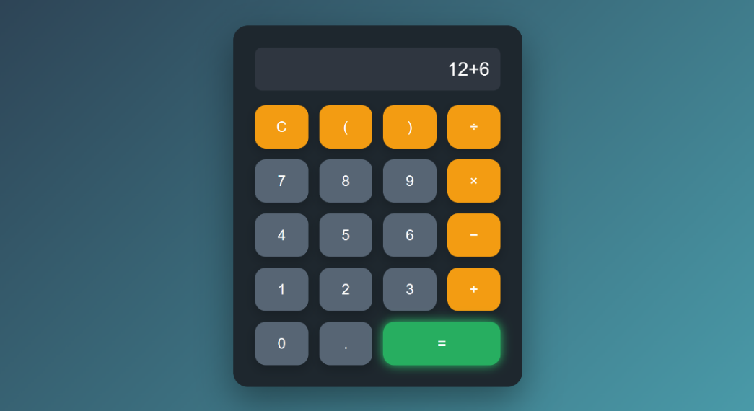
🔹 Output Display:
- Result instantly shown inside the input field.
- Clear and Backspace update output dynamically.
- Responsive UI that scales on mobile screens

SYSTEM TESTING
System testing is a critical phase in the software development lifecycle. It ensures that the final product meets user requirements, functions as expected, and performs well under different scenarios. Each project developed during the internship was tested thoroughly using manual testing methods across browsers and devices.
Testing Goals
- Validate UI responsiveness and consistency across devices.
- Ensure that all inputs and outputs behave as expected.
- Identify and resolve any errors or bugs before final submission.
- Verify that each feature works under normal and edge-case conditions.
Manual Testing Tools Used
Tool | Purpose
Google Chrome | Browser compatibility and responsive view
Firefox | Cross-browser testing
Chrome DevTools | Mobile simulation and debugging
VS Code Live Server | Real-time testing during development

Final Testing Verdict
- All test cases were passed successfully.
- User interaction was smooth and intuitive.
- Interfaces were visually responsive and worked on different screen sizes.
- All logic-related functionalities were accurate and stable.
Conclusion:
Each project was tested under multiple conditions and passed all functional, usability, and responsiveness criteria. The system is considered stable, user-ready, and visually polished for deployment or demonstration.

SYSTEM IMPLEMENTATION
System implementation is the process of deploying the developed solution into a functional environment where it can be accessed, tested, or used by end users. It involves setting up the necessary hardware and software environment, writing final code, testing integrations, and making the system live (if applicable).

1. Hardware Requirements
The following configuration was used during the internship for coding, testing, and documenting the projects:

Component | Specification
Processor | Intel Core i3/i5 or AMD Ryzen equivalent
RAM | Minimum 4 GB (8 GB Recommended)
Storage | Minimum 6 GB Free Space
Operating System | Windows 11 / Ubuntu 22.04
Display | 13" or higher HD Screen
Input Devices | Keyboard and Mouse
Internet | Required for research, tools, and GitHub
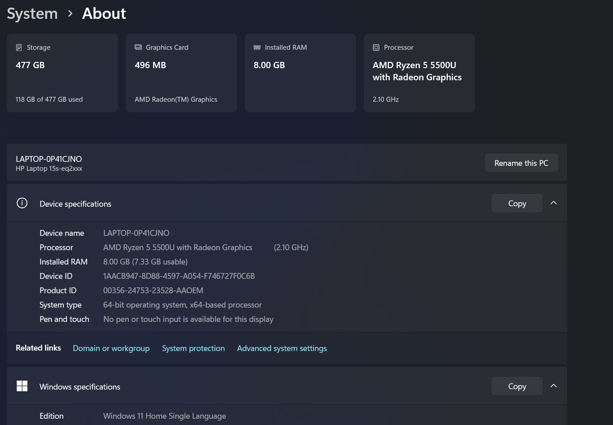

2. Software Requirements
All tools used were free, open-source, or browser-based.

Software | Purpose | Type
Visual Studio Code | Code editor for HTML, CSS, and JavaScript | Open Source
Google Chrome | Testing and live preview | Freeware
GitHub (optional) | Version control and project hosting | Free Platform
Draw.io / Canva | Flowcharts, DFDs, Gantt Chart | Web-based
Chrome DevTools | Mobile/responsive layout testing | Built-in

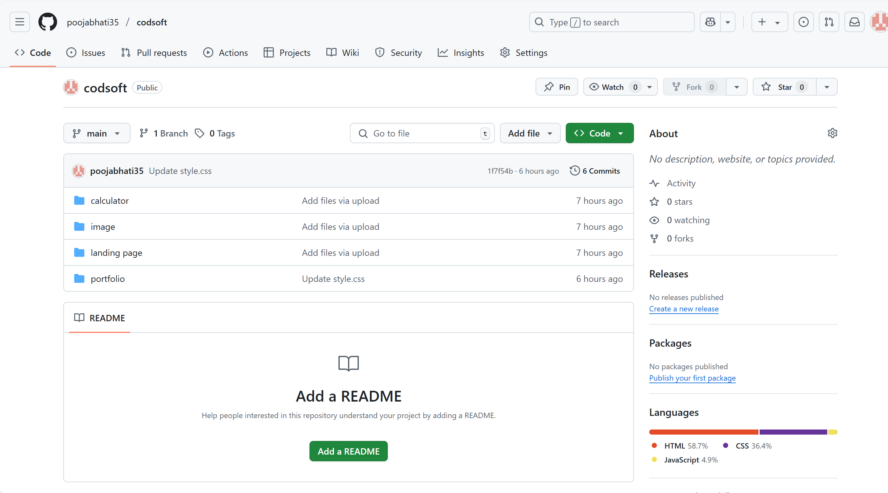

CONCLUSION :
The implementation process was simple, efficient, and cost-free. Using lightweight tools and a task-wise plan helped complete all projects well within the internship timeline.

DOCUMENTATION
Documentation provides a structured explanation of all the files, folders, and resources used in the project. It helps future developers or evaluators understand the purpose of each component and how the system functions as a whole.
For this internship, three frontend web projects were built. Each was organized into clearly labeled directories and used best practices in file naming and modular code structure.
  - Portfolio Website Documentation

File Name | Description
index.html | Main HTML file containing sections: Home, About, Skills, Projects, and Contact.
style.css | Styles the layout, fonts, colors, responsiveness, and hover effects.
script.js | Optional JavaScript for form animations or nav toggles.
/assets/ | Stores all image assets including profile pictures, background icons, etc.

  - Landing Page Documentation
File Name | Description
index.html | Main layout of the landing page (hero, features, testimonials, footer, etc.)
style.css | Defines layout styling, mobile responsiveness, hover animations, and font styles
script.js | Optional JavaScript for form animations or nav toggles.
/assets/ | Contains background images, icons, and decorative elements

3.Calculator Project Documentation

File Name | Description
index.html | Contains the calculator interface: display and clickable buttons
style.css | Styles the buttons, input field, and layout (grid/flexbox)
script.js | Core logic for calculation, clear, delete, and evaluation

Conclusion:
All projects are well-documented, modular, and easy to navigate. Any developer reviewing this folder structure will understand each component’s role, making further development or upgrades easy.

SCOPE OF THE PROJECT
The scope of this internship extends far beyond the basics of frontend web development. It showcases the practical implementation of design aesthetics, logical structuring, responsive layouts, and interactive user experiences through hands-on, real-world projects.
The three completed systems—Personal Portfolio Website, Web-Based Calculator, and Product Landing Page—not only serve immediate functional purposes but also hold significant potential for further enhancement and adaptation.
This section outlines the broader applicability of these solutions and how they can be upgraded or repurposed for use in academic portfolios, professional branding, client-based projects, or scalable web platforms.

1.Portfolio Website – Professional Self-Branding
The Portfolio Website is more than just a web page. It is a digital identity that can:
- Be shared with recruiters, internship providers, and clients.
- Showcase technical skills, projects, and achievements.

🔹 Future Scope:
- Integrate a backend (e.g., Firebase, Node.js) to store form responses.
- Add project filtering, search, or portfolio gallery using JavaScript.

2. Landing Page – Business or Startup Promotion
The landing page mimics a real-world product or service promotion page. It can be adapted for:
- Freelance clients in need of promotional websites.
- Startups or NGOs for campaign-based one-pagers.
🔹 Future Scope:
- Connect to email marketing platforms (Mailchimp, etc.).
- Add animations, testimonials slider, or pricing tables.

3. Calculator – Logic Enhancement and Use in Applications
This simple calculator has a wide scope of extension and use in various utility applications such as:
- Educational tools or learning platforms for basic arithmetic.
- Conversion tools (e.g., temperature, currency, BMI calculators).
🔹 Future Scope:
- Extend functionality to scientific calculator features.
- Store history of calculations with local storage or backend.

4. Internship & Career Impact
These projects build foundational skills essential for:
- Internships in frontend and full-stack development.
- Freelancing with web clients on platforms like Upwork or Fiverr.
- Academic projects in the 3rd or final year.
- Preparing for job roles like Web Developer, UI/UX Designer, Frontend Engineer.

Conclusion:
The scope of this internship project is scalable, flexible, and aligned with industry needs. With minor extensions, each system can evolve into a professional-grade application that supports both academic excellence and career advancement.

BIBLIOGRAPHY :
1. Online Learning & Documentation
- Referred W3Schools for basic syntax and implementation examples of HTML, CSS, and JavaScript.
- Used MDN Web Docs for in-depth, standard-based documentation of web technologies.
- Followed articles on CSS-Tricks for tips and solutions related to responsive design, Flexbox, and CSS Grid.
- Used Stack Overflow to resolve coding errors and logic-based issues during development.
2. Tools and Platforms
- Used Visual Studio Code as the primary code editor for writing and managing code.
- Tested and debugged applications on Google Chrome and Mozilla Firefox browsers.
- Employed GitHub (optional) for version control and project hosting.
- Created flowcharts and DFD diagrams using Draw.io / Diagrams.net.
- Utilized Canva to design UI references, banners, and visual elements.

3. Asset & Icon Libraries
- Integrated FontAwesome for icons in buttons, menus, and feature highlights.
- Applied custom fonts from Google Fonts to enhance interface typography.
- Sourced high-quality, royalty-free images from Unsplash (optional use).
- Used Flaticon for clean and professional flat icons across the project.

